ACADEMIA DE STUDII ECONOMICE DIN BUCUREȘTI

FACULTATEA DE CIBERNETICĂ, STATISTICĂ SI INFORMATICĂ ECONOMICĂ

SPECIALIZAREA DE INFORMATICĂ ECONOMICĂ

**PROIECT – BAZE DE DATE**

PROFESOR COORDONATOR:

BOTHA IULIANA

STUDENT:

SIMIONESCU CORINA ANDREEA

BUCUREȘTI

2023-2024

Table of Content

**I.** **DESCRIEREA PROBLEMEI ȘI SCHEMA CONCEPTUALĂ** 4

**1. Descrierea problemei alese** 4

**2. Schema conceptuală a bazei de date** 5

**II.** **DEFINIREA SCHEMEI BAZEI DE DATE** 6

**1. Implementarea operaţiilor de definire a datelor: CREATE, ALTER, DROP** 6

**2. Schema conceptuală a bazei de date generată de Oracle SQL Developer** 13

**III.** **IMPLEMENTAREA OPERAȚIILOR DE ACTUALIZARE A DATELOR** 14

**1. INSERT** 14

**1.1 Datele inserate in tabele** 23

**2. UPDATE** 26

**3. DELETE** 26

**IV.** **IMPLEMENTAREA INTEROGĂRILOR** 27

**1. JONCȚIUNI** 27

**1.1. INNER JOIN** 27

**1.2. OUTER JOIN** 28

**1.3. LEFT JOIN** 29

**1.4. RIGHT JOIN** 30

**2. FUNCȚII DE GRUP** 31

**2.1. COUNT** 31

**2.2. SUM** 32

**2.3. MIN** 34

**2.4. MAX** 35

**2.5. AVG** 35

**3. FUNCȚII SINGLE-ROW** 36

**3.1. FUNCȚII NUMERICE** 36

**3.1.1. ROUND** 36

**3.1.2. TRUNC** 36

**3.2. FUNCTII DE CARACTERE** 37

**3.2.1. LOWER** 37

**3.2.2. UPPER** 37

**3.2.3. INITCAP** 38

**3.2.4. OPERATORUL DE CONCATENARE: ||** 39

**3.2.5. SUBSTR** 39

**3.2.6. CONCAT SI LENGTH** 40

**3.3. FUNCȚII DE TIP DATĂ CALENDARISTICĂ** 41

**3.3.1. SYSDATE** 41

**3.3.2. MONTH_BETWEEN() , NEXT_DAY() , LAST_DAY(), ADD_MONTHS()** 41

**4. REALIZAREA INTEROGĂRILOR PE BAZA UNOR CONDIȚII** 42

**4.1. DECODE** 42

**4.2. CASE** 43

**5. OPERATORII ALGEBREI RELAȚIONALE** 44

**5.1. MINUS** 44

**5.2. INTERSECT** 45

**5.3. UNION** 45

**6. SUBCERERI** 46

**V.** **GESTIUNEA ALTOR OBIECTE ALE BAZEI DE DATE** 50

**1. TABELE VIRTUALE** 50

**1.1. CREARE TABELĂ VIRTUALĂ** 50

**1.2. INTEROGARE TABELĂ VIRTUALĂ** 52

**1.3. STERGERE TABELĂ VIRTUALĂ** 53

**2. INDECȘI** 53

**2.1. CREARE INDEX** 53

**2.2. VIZUALIZARE INDECȘI** 54

**2.3. EFICIENTA INDECȘILOR** 54

**2.4. STERGERE INDECȘI** 56

**3. SINONIME** 56

**3.1. CREARE SINONIM** 56

**3.2. UTILIZAREA SINONIMULUI CREAT** 57

**3.3. VIZUALIZARE SINONIME** 57

**3.4. STERGERE SINONIM** 57

**4. SECVENȚE** 58

**4.1. CREARE SECVENȚĂ** 58

**4.2. UTILIZAREA SECVENȚEI CREATE** 58

**4.3. AFISARE VALOARE CURENTĂ A SECVENȚEI** 59

**4.4. STERGERE SECVENȚĂ** 60

# **DESCRIEREA PROBLEMEI ȘI SCHEMA CONCEPTUALĂ**

## **1. Descrierea problemei alese**

Baza de date este concepută pentru a gestiona informațiile unui site de vânzare de laptopuri.

Atunci când un utilizator se loghează pe site, acesta trebuie să introducă informații precum nume, prenume, adresă de e-mail, număr de telefon și adresă. Adresa este asociată cu o țară și un oraș, iar acestea sunt preluate din tabelele Z_COUNTRIES și Z_CITIES, asigurând astfel integritatea referențială.

După logare, utilizatorul poate naviga prin catalogul de laptopuri, care sunt stocate în tabela Z_LAPTOPS. Fiecare laptop are detalii precum brand, model, tip de procesor, dimensiunea ecranului, capacitatea de stocare SSD, placă grafică, sistem de operare și preț.

Atunci când un utilizator decide să plaseze o comandă, este creată o înregistrare în tabela Z_LAPTOP_ORDERS, cu detalii precum data comenzii, metoda de livrare și statusul comenzii. Metodele de livrare sunt gestionate în tabela Z_SHIPPING_METHODS.

Fiecare linie a comenzii este detaliată în tabela Z_ORDER_LINES, indicând laptopul comandat, cantitatea și prețul. Aceste detalii sunt legate de tabelul Z_LAPTOP_ORDERS și Z_LAPTOPS prin foreign keys.

## **2. Schema conceptuală a bazei de date**

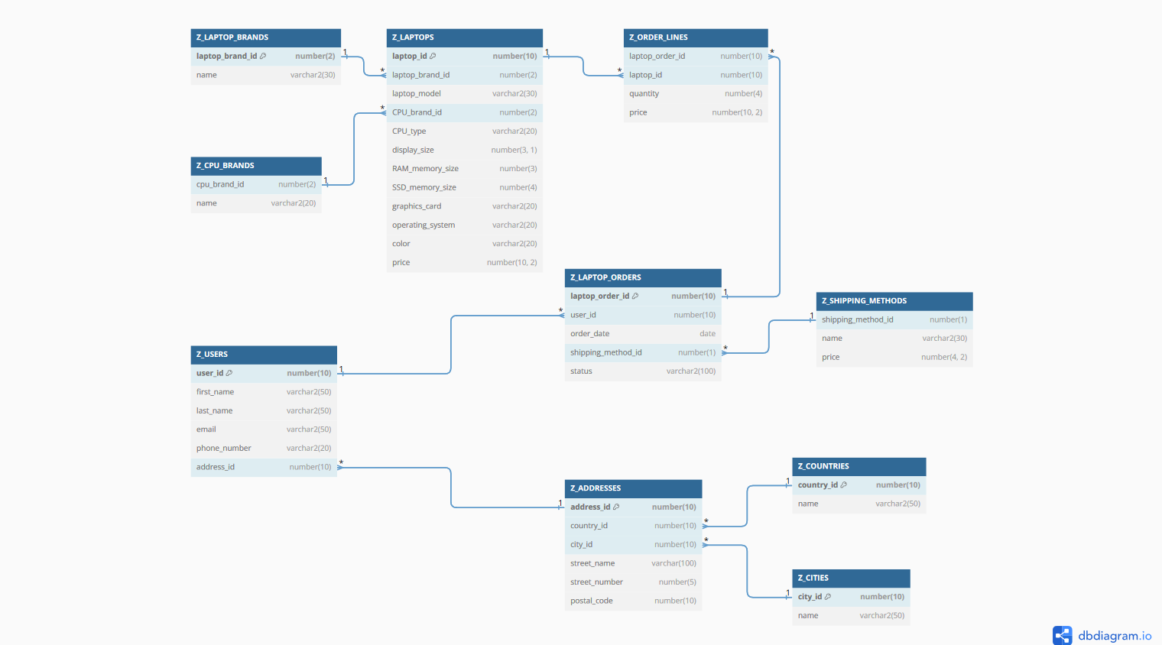

# **DEFINIREA SCHEMEI BAZEI DE DATE**

## **1. Implementarea operaţiilor de definire a datelor: CREATE, ALTER, DROP**

DROP TABLE Z_USERS CASCADE CONSTRAINTS;

DROP TABLE Z_ADDRESSES CASCADE CONSTRAINTS;

DROP TABLE Z_COUNTRIES CASCADE CONSTRAINTS;

DROP TABLE Z_CITIES CASCADE CONSTRAINTS;

DROP TABLE Z_LAPTOPS CASCADE CONSTRAINTS;

DROP TABLE Z_LAPTOP_BRANDS CASCADE CONSTRAINTS;

DROP TABLE Z_CPU_BRANDS CASCADE CONSTRAINTS;

DROP TABLE Z_ORDER_LINES CASCADE CONSTRAINTS;

DROP TABLE Z_LAPTOP_ORDERS CASCADE CONSTRAINTS;

DROP TABLE Z_SHIPPING_METHODS CASCADE CONSTRAINTS;

prompt

prompt Creating table Z_COUNTRIES

prompt ======================

prompt

CREATE TABLE Z_COUNTRIES

(

COUNTRY_ID NUMBER(10) CONSTRAINT PK_COUNTRY_ID PRIMARY KEY,

NAME VARCHAR2(50) CONSTRAINT NN_COUNTRY_NAME NOT NULL

CONSTRAINT UNQ_COUNTRY_NAME UNIQUE

);

prompt

prompt Creating table Z_CITIES

prompt ======================

prompt

CREATE TABLE Z_CITIES

(

CITY_ID NUMBER(10) CONSTRAINT PK_CITY_ID PRIMARY KEY,

NAME VARCHAR2(50) CONSTRAINT NN_CITY_NAME NOT NULL

CONSTRAINT UNQ_CITY_NAME UNIQUE

);

prompt

prompt Creating table Z_ADDRESSES

prompt ======================

prompt

CREATE TABLE Z_ADDRESSES

(

ADDRESS_ID NUMBER(10) CONSTRAINT PK_ADDRESS_ID PRIMARY KEY,

COUNTRY_ID NUMBER(10) CONSTRAINT NN_COUNTRY_ID NOT NULL,

CITY_ID NUMBER(10) CONSTRAINT NN_CITY_ID NOT NULL,

STREET_NAME VARCHAR2(100),

STREET_NUMBER NUMBER(5),

POSTAL_CODE NUMBER(10)

);

ALTER TABLE Z_ADDRESSES

ADD CONSTRAINT FK_COUNTRY_ID FOREIGN KEY (COUNTRY_ID)

REFERENCES Z_COUNTRIES (COUNTRY_ID);

ALTER TABLE Z_ADDRESSES

ADD CONSTRAINT FK_CITY_ID FOREIGN KEY (CITY_ID)

REFERENCES Z_CITIES (CITY_ID);

prompt

prompt Creating table Z_USERS

prompt ======================

prompt

CREATE TABLE Z_USERS

(

USER_ID NUMBER(10) CONSTRAINT PK_USER_ID PRIMARY KEY,

FIRST_NAME VARCHAR2(50) CONSTRAINT NN_FIRST_NAME NOT NULL,

LAST_NAME VARCHAR(50) CONSTRAINT NN_LAST_NAME NOT NULL,

EMAIL VARCHAR2(50) CONSTRAINT NN_EMAIL NOT NULL,

PHONE_NUMBER VARCHAR2(20),

ADDRESS_ID NUMBER(10)

);

ALTER TABLE Z_USERS

ADD CONSTRAINT FK_ADDRESS_ID FOREIGN KEY (ADDRESS_ID)

REFERENCES Z_ADDRESSES (ADDRESS_ID);

prompt

prompt Creating table Z_SHIPPING_METHODS

prompt ======================

prompt

CREATE TABLE Z_SHIPPING_METHODS

(

SHIPPING_METHOD_ID NUMBER(1) CONSTRAINT PK_SHIPPING_METHOD_ID PRIMARY KEY,

NAME VARCHAR2(30) CONSTRAINT NN_SHIPPING_METHOD_NAME NOT NULL

CONSTRAINT UNQ_SHIPPING_METHOD_NAME UNIQUE,

PRICE NUMBER(4,2) CONSTRAINT NN_PRICE NOT NULL

);

ALTER TABLE Z_SHIPPING_METHODS

ADD CONSTRAINT CHK_SHIPPING_PRICE CHECK (PRICE >= 0);

prompt

prompt Creating table Z_SHIPPING_METHODS

prompt ======================

prompt

CREATE TABLE Z_LAPTOP_ORDERS

(

LAPTOP_ORDER_ID NUMBER(10) CONSTRAINT PK_LAPTOP_ORDER_ID PRIMARY KEY,

USER_ID NUMBER(10) CONSTRAINT NN_USER_ID NOT NULL,

ORDER_DATE DATE,

SHIPPING_METHOD_ID NUMBER(1) CONSTRAINT NN_SHIPPING_METHOD_ID NOT NULL,

STATUS VARCHAR2(100)

);

ALTER TABLE Z_LAPTOP_ORDERS

ADD CONSTRAINT FK_USER_ID FOREIGN KEY (USER_ID)

REFERENCES Z_USERS (USER_ID);

ALTER TABLE Z_LAPTOP_ORDERS

ADD CONSTRAINT FK_SHIPPING_METHOD_ID FOREIGN KEY (SHIPPING_METHOD_ID)

REFERENCES Z_SHIPPING_METHODS (SHIPPING_METHOD_ID);

prompt

prompt Creating table Z_LAPTOP_BRANDS

prompt ======================

prompt

CREATE TABLE Z_LAPTOP_BRANDS

(

LAPTOP_BRAND_ID NUMBER(2) CONSTRAINT PK_LAPTOP_BRAND_ID PRIMARY KEY,

NAME VARCHAR2(30) CONSTRAINT NN_LAPTOP_BRAND_NAME NOT NULL

CONSTRAINT UNQ_LAPTOP_BRAND_NAME UNIQUE

);

prompt

prompt Creating table Z_CPU_BRANDS

prompt ======================

prompt

CREATE TABLE Z_CPU_BRANDS

(

CPU_BRAND_ID NUMBER(2) CONSTRAINT PK_CPU_BRAND_ID PRIMARY KEY,

NAME VARCHAR2(20) CONSTRAINT NN_CPU_BRAND_NAME NOT NULL

CONSTRAINT UNQ_CPU_BRAND_NAME UNIQUE

);

prompt

prompt Creating table Z_LAPTOPS

prompt ======================

prompt

CREATE TABLE Z_LAPTOPS

(

LAPTOP_ID NUMBER(10) CONSTRAINT PK_LAPTOP_ID PRIMARY KEY,

LAPTOP_BRAND_ID NUMBER(2) CONSTRAINT NN_LAPTOP_BRAND_ID NOT NULL,

LAPTOP_MODEL VARCHAR2(30),

CPU_BRAND_ID NUMBER(2) CONSTRAINT NN_CPU_BRAND_ID NOT NULL,

CPU_TYPE VARCHAR2(20),

DISPLAY_SIZE NUMBER(3,1),

RAM_MEMORY_SIZE NUMBER(3),

SSD_MEMORY_SIZE NUMBER(4),

GRAPHICS_CARD VARCHAR2(20),

OPERATING_SYSTEM VARCHAR2(20),

COLOR VARCHAR2(20),

PRICE NUMBER(10, 2)

);

ALTER TABLE Z_LAPTOPS

ADD CONSTRAINT FK_LAPTOP_BRAND_ID FOREIGN KEY (LAPTOP_BRAND_ID)

REFERENCES Z_LAPTOP_BRANDS (LAPTOP_BRAND_ID);

ALTER TABLE Z_LAPTOPS

ADD CONSTRAINT FK_CPU_BRAND_ID FOREIGN KEY (CPU_BRAND_ID)

REFERENCES Z_CPU_BRANDS (CPU_BRAND_ID);

prompt

prompt Creating table Z_ORDER_LINES

prompt ======================

prompt

CREATE TABLE Z_ORDER_LINES

(

LAPTOP_ORDER_ID NUMBER(10) CONSTRAINT NN_LAPTOP_ORDER_ID NOT NULL,

LAPTOP_ID NUMBER(10) CONSTRAINT NN_LAPTOP_ID NOT NULL,

QUANTITY NUMBER(4) CONSTRAINT NN_QUANTITY NOT NULL,

PRICE NUMBER(10, 2) CONSTRAINT NN_ORDER_LINE_PRICE NOT NULL

);

ALTER TABLE Z_ORDER_LINES

ADD CONSTRAINT FK_LAPTOP_ORDER_ID FOREIGN KEY (LAPTOP_ORDER_ID)

REFERENCES Z_LAPTOP_ORDERS (LAPTOP_ORDER_ID);

ALTER TABLE Z_ORDER_LINES

ADD CONSTRAINT FK_LAPTOP_ID FOREIGN KEY (LAPTOP_ID)

REFERENCES Z_LAPTOPS (LAPTOP_ID);

ALTER TABLE Z_ORDER_LINES

ADD CONSTRAINT CHK_ORDER_LINE_QUANTITY CHECK (QUANTITY >= 1);

ALTER TABLE Z_ORDER_LINES

ADD CONSTRAINT CHK_ORDER_LINE_PRICE CHECK (PRICE >= 0);

## **2. Schema conceptuală a bazei de date generată de Oracle SQL Developer**

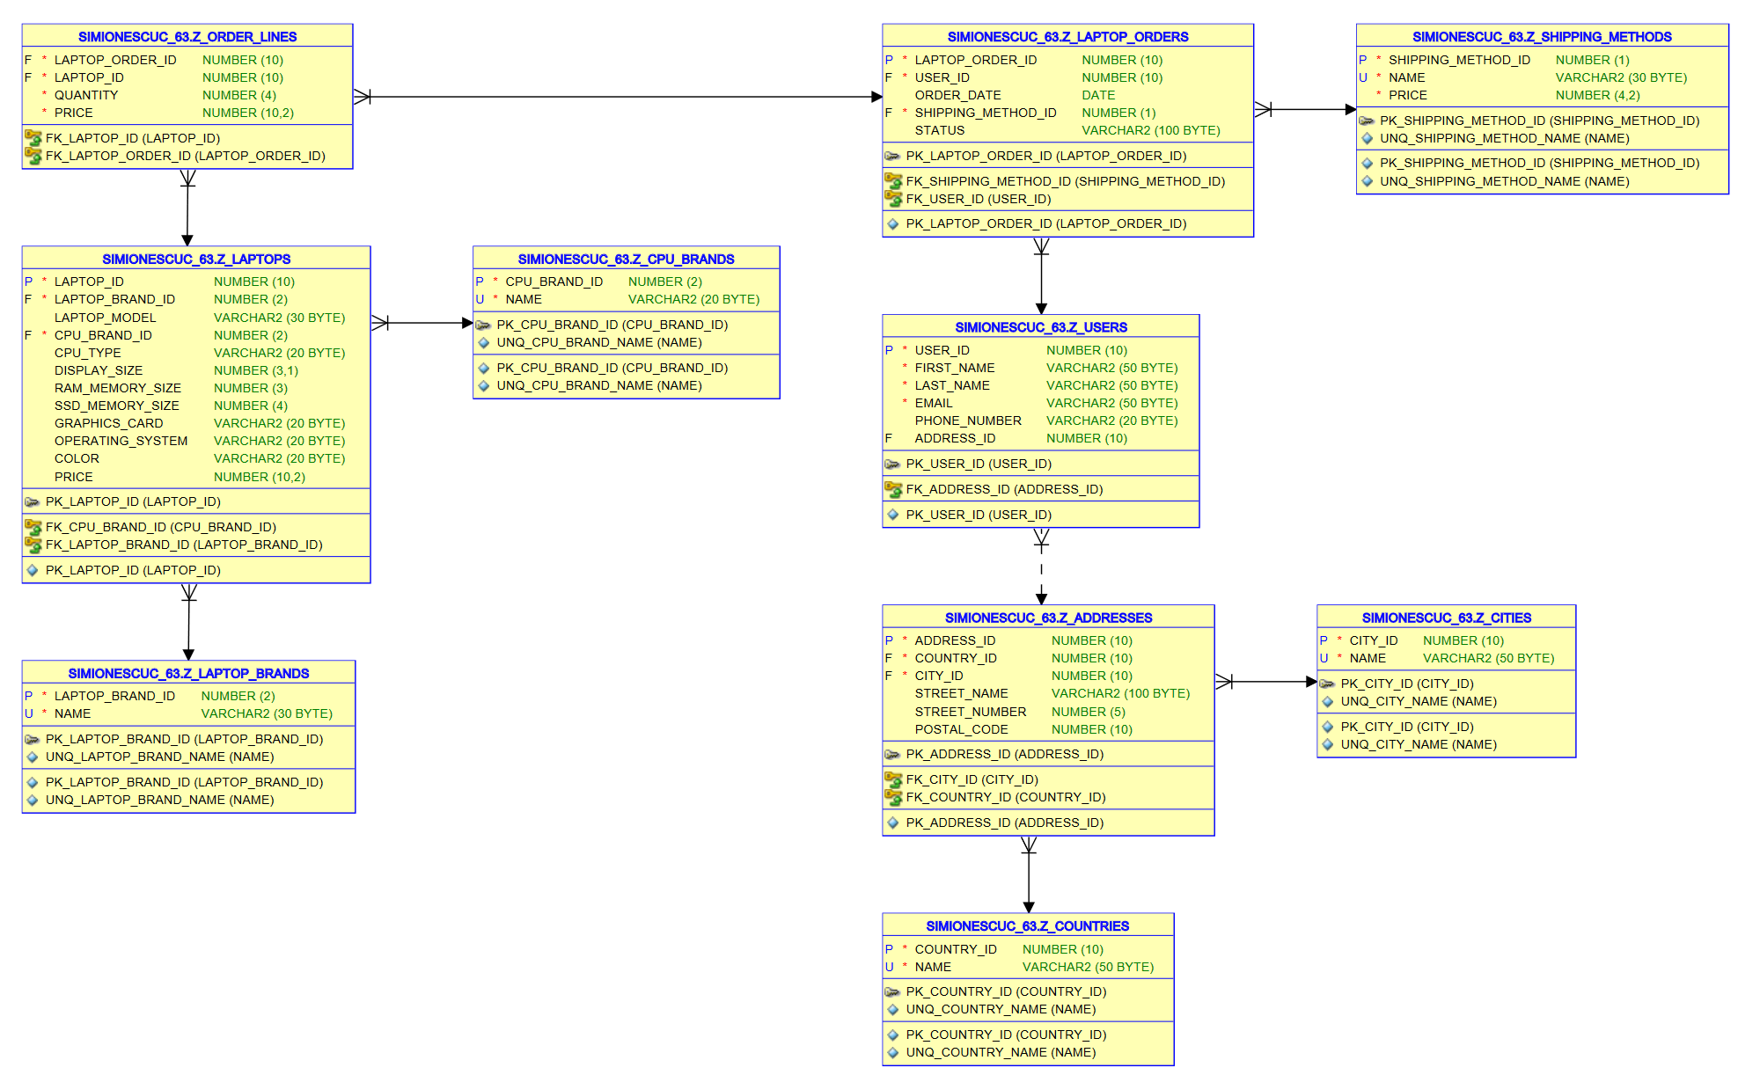

# **IMPLEMENTAREA OPERAȚIILOR DE ACTUALIZARE A DATELOR**

## **1. INSERT**

prompt Loading Z_CITIES

INSERT INTO Z_CITIES (CITY_ID, NAME)

VALUES (1, 'Bucuresti');

INSERT INTO Z_CITIES (CITY_ID, NAME)

VALUES (2, 'Cluj');

INSERT INTO Z_CITIES (CITY_ID, NAME)

VALUES (3, 'Caracal');

INSERT INTO Z_CITIES (CITY_ID, NAME)

VALUES (4, 'Craiova');

INSERT INTO Z_CITIES (CITY_ID, NAME)

VALUES (5, 'Targu Mures');

INSERT INTO Z_CITIES (CITY_ID, NAME)

VALUES (6, 'Roma');

INSERT INTO Z_CITIES (CITY_ID, NAME)

VALUES (7, 'Milano');

INSERT INTO Z_CITIES (CITY_ID, NAME)

VALUES (8, 'Barcelona');

INSERT INTO Z_CITIES (CITY_ID, NAME)

VALUES (9, 'Madrid');

INSERT INTO Z_CITIES (CITY_ID, NAME)

VALUES (10, 'Salamanca');

prompt 10 records loaded

prompt Loading Z_COUNTRIES

INSERT INTO Z_COUNTRIES (COUNTRY_ID, NAME)

VALUES (1, 'Romania');

INSERT INTO Z_COUNTRIES (COUNTRY_ID, NAME)

VALUES (2, 'Italia');

INSERT INTO Z_COUNTRIES (COUNTRY_ID, NAME)

VALUES (3, 'Spania');

INSERT INTO Z_COUNTRIES (COUNTRY_ID, NAME)

VALUES (4, 'Austria');

INSERT INTO Z_COUNTRIES (COUNTRY_ID, NAME)

VALUES (5, 'Anglia');

prompt 5 records loaded

prompt Loading Z_ADDRESSES

INSERT INTO Z_ADDRESSES (ADDRESS_ID, COUNTRY_ID, CITY_ID, STREET_NAME, STREET_NUMBER, POSTAL_CODE)

VALUES (1, 1, 1, 'Strada 1', 10, 1000);

INSERT INTO Z_ADDRESSES (ADDRESS_ID, COUNTRY_ID, CITY_ID, STREET_NAME, STREET_NUMBER, POSTAL_CODE)

VALUES (2, 1, 1, 'Strada 2', 20, 2000);

INSERT INTO Z_ADDRESSES (ADDRESS_ID, COUNTRY_ID, CITY_ID, STREET_NAME, STREET_NUMBER, POSTAL_CODE)

VALUES (3, 1, 2, 'Strada 3', 30, 3000);

INSERT INTO Z_ADDRESSES (ADDRESS_ID, COUNTRY_ID, CITY_ID)

VALUES (4, 2, 7);

INSERT INTO Z_ADDRESSES (ADDRESS_ID, COUNTRY_ID, CITY_ID)

VALUES (5, 2, 6);

INSERT INTO Z_ADDRESSES (ADDRESS_ID, COUNTRY_ID, CITY_ID)

VALUES (6, 2, 6);

INSERT INTO Z_ADDRESSES (ADDRESS_ID, COUNTRY_ID, CITY_ID)

VALUES (7, 3, 8);

INSERT INTO Z_ADDRESSES (ADDRESS_ID, COUNTRY_ID, CITY_ID)

VALUES (8, 3, 8);

INSERT INTO Z_ADDRESSES (ADDRESS_ID, COUNTRY_ID, CITY_ID)

VALUES (9, 3, 8);

prompt 9 records loaded

prompt Loading Z_USERS

INSERT INTO Z_USERS(USER_ID, FIRST_NAME, LAST_NAME, EMAIL, PHONE_NUMBER, ADDRESS_ID)

VALUES (1, 'Corina', 'Simionescu', 'corina.simionescu12@gmail.com', '0766111111', 1);

INSERT INTO Z_USERS(USER_ID, FIRST_NAME, LAST_NAME, EMAIL, PHONE_NUMBER, ADDRESS_ID)

VALUES (2, 'Mihai', 'Ionescu', 'mihai.ionescu@gmail.com', '0766222222', 1);

INSERT INTO Z_USERS(USER_ID, FIRST_NAME, LAST_NAME, EMAIL, PHONE_NUMBER, ADDRESS_ID)

VALUES (3, 'Ana', 'Aremere', 'ana.aremere@gmail.com', '0766333333', 2);

INSERT INTO Z_USERS(USER_ID, FIRST_NAME, LAST_NAME, EMAIL, PHONE_NUMBER, ADDRESS_ID)

VALUES (4, 'Matei', 'Florin', 'matei.florin@gmail.com', '0766444444', 3);

INSERT INTO Z_USERS(USER_ID, FIRST_NAME, LAST_NAME, EMAIL)

VALUES (5, 'Cristian', 'Cantemir', 'cristian.cantemir@gmail.com');

INSERT INTO Z_USERS(USER_ID, FIRST_NAME, LAST_NAME, EMAIL)

VALUES (6, 'Oana', 'Diaconu', 'oana.diaconu@gmail.com');

INSERT INTO Z_USERS(USER_ID, FIRST_NAME, LAST_NAME, EMAIL)

VALUES (7, 'Ionut', 'Volintiru', 'ionut.volintiru@gmail.com');

INSERT INTO Z_USERS(USER_ID, FIRST_NAME, LAST_NAME, EMAIL)

VALUES (8, 'Daria', 'Ispas', 'daria.ispas@gmail.com');

INSERT INTO Z_USERS(USER_ID, FIRST_NAME, LAST_NAME, EMAIL)

VALUES (9, 'Miron', 'Stanciu', 'miron.stanciu@gmail.com');

INSERT INTO Z_USERS(USER_ID, FIRST_NAME, LAST_NAME, EMAIL, ADDRESS_ID)

VALUES (10, 'Leonardo', 'Davinci', 'leonardo.davinci@gmail.com', 4);

INSERT INTO Z_USERS(USER_ID, FIRST_NAME, LAST_NAME, EMAIL, ADDRESS_ID)

VALUES (11, 'Elena', 'Agostini', 'elena.agostini@gmail.com', 4);

INSERT INTO Z_USERS(USER_ID, FIRST_NAME, LAST_NAME, EMAIL, ADDRESS_ID)

VALUES (12, 'Sofia', 'Lombardi', 'sofia.lombardi@gmail.com', 5);

INSERT INTO Z_USERS(USER_ID, FIRST_NAME, LAST_NAME, EMAIL, ADDRESS_ID)

VALUES (13, 'Alessandro', 'Fontana', 'alessandro.fontana@gmail.com', 6);

INSERT INTO Z_USERS(USER_ID, FIRST_NAME, LAST_NAME, EMAIL, ADDRESS_ID)

VALUES (14, 'Pablo', 'Escobar', 'pablo.escobar@gmail.com', 7);

INSERT INTO Z_USERS(USER_ID, FIRST_NAME, LAST_NAME, EMAIL, ADDRESS_ID)

VALUES (15, 'Mateo', 'Fernanez', 'mateo.fernandez@gmail.com', 8);

INSERT INTO Z_USERS(USER_ID, FIRST_NAME, LAST_NAME, EMAIL, ADDRESS_ID)

VALUES (16, 'Martina', 'Lopez', 'martina.lopez@gmail.com', 9);

prompt 16 records loaded

prompt Loading Z_SHIPPING_METHODS

INSERT INTO Z_SHIPPING_METHODS(SHIPPING_METHOD_ID, NAME, PRICE)

VALUES (1, 'Fan Courier', 15);

INSERT INTO Z_SHIPPING_METHODS(SHIPPING_METHOD_ID, NAME, PRICE)

VALUES (2, 'Sameday', 30);

INSERT INTO Z_SHIPPING_METHODS(SHIPPING_METHOD_ID, NAME, PRICE)

VALUES (3, 'EasyBox', 0);

prompt 3 records loaded

prompt Loading Z_LAPTOP_BRANDS

INSERT INTO Z_LAPTOP_BRANDS(LAPTOP_BRAND_ID, NAME)

VALUES (1, 'Apple');

INSERT INTO Z_LAPTOP_BRANDS(LAPTOP_BRAND_ID, NAME)

VALUES (2, 'Lenovo');

INSERT INTO Z_LAPTOP_BRANDS(LAPTOP_BRAND_ID, NAME)

VALUES (3, 'Asus');

prompt 3 records loaded

prompt Loading Z_CPU_BRANDS

INSERT INTO Z_CPU_BRANDS(CPU_BRAND_ID, NAME)

VALUES (1, 'Apple');

INSERT INTO Z_CPU_BRANDS(CPU_BRAND_ID, NAME)

VALUES (2, 'Intel');

INSERT INTO Z_CPU_BRANDS(CPU_BRAND_ID, NAME)

VALUES (3, 'AMD');

prompt 3 records loaded

prompt Loading Z_LAPTOPS

INSERT INTO Z_LAPTOPS(LAPTOP_ID, LAPTOP_BRAND_ID, LAPTOP_MODEL, CPU_BRAND_ID, CPU_TYPE, DISPLAY_SIZE, RAM_MEMORY_SIZE, SSD_MEMORY_SIZE, GRAPHICS_CARD, OPERATING_SYSTEM, COLOR, PRICE)

VALUES (1, 1, 'MacBook Pro', 1, 'M1', 14, 16, 512, NULL, 'MacOS', 'grey', 10000);

INSERT INTO Z_LAPTOPS(LAPTOP_ID, LAPTOP_BRAND_ID, LAPTOP_MODEL, CPU_BRAND_ID, CPU_TYPE, DISPLAY_SIZE, RAM_MEMORY_SIZE, SSD_MEMORY_SIZE, GRAPHICS_CARD, OPERATING_SYSTEM, COLOR, PRICE)

VALUES (2, 2, 'Yoga Slim 7 Pro', 3, 'Ryzen 7', 14, 16, 512, 'Integrata', NULL, 'cloud grey', 5000);

INSERT INTO Z_LAPTOPS(LAPTOP_ID, LAPTOP_BRAND_ID, LAPTOP_MODEL, CPU_BRAND_ID, CPU_TYPE, DISPLAY_SIZE, RAM_MEMORY_SIZE, SSD_MEMORY_SIZE, GRAPHICS_CARD, OPERATING_SYSTEM, COLOR, PRICE)

VALUES (3, 2, 'IdeaPad Slim 5', 2, 'I5', 16, 16, 512, 'Integrata', 'Windows 11', 'black', 3000);

INSERT INTO Z_LAPTOPS(LAPTOP_ID, LAPTOP_BRAND_ID, LAPTOP_MODEL, CPU_BRAND_ID, CPU_TYPE, DISPLAY_SIZE, RAM_MEMORY_SIZE, SSD_MEMORY_SIZE, GRAPHICS_CARD, OPERATING_SYSTEM, COLOR, PRICE)

VALUES (4, 2, 'LOQ', 2, 'I5', 15.6, 16, 512, 'Dedicata', 'Linux', 'black', 5000);

INSERT INTO Z_LAPTOPS(LAPTOP_ID, LAPTOP_BRAND_ID, LAPTOP_MODEL, CPU_BRAND_ID, CPU_TYPE, DISPLAY_SIZE, RAM_MEMORY_SIZE, SSD_MEMORY_SIZE, GRAPHICS_CARD, OPERATING_SYSTEM, COLOR, PRICE)

VALUES (5, 2, 'ThinkPad', 2, 'Xeon', 15.6, 32, 1000, 'Dedicata', 'Windows 10 Pro', 'black', 35000);

INSERT INTO Z_LAPTOPS(LAPTOP_ID, LAPTOP_BRAND_ID, LAPTOP_MODEL, CPU_BRAND_ID, CPU_TYPE, DISPLAY_SIZE, RAM_MEMORY_SIZE, SSD_MEMORY_SIZE, GRAPHICS_CARD, OPERATING_SYSTEM, COLOR, PRICE)

VALUES (6, 1, 'MacBook Air', 1, 'M2', 15.3, 8, 512, 'Integrata', 'MacOS', 'starlight', 9000);

INSERT INTO Z_LAPTOPS(LAPTOP_ID, LAPTOP_BRAND_ID, LAPTOP_MODEL, CPU_BRAND_ID, CPU_TYPE, DISPLAY_SIZE, RAM_MEMORY_SIZE, SSD_MEMORY_SIZE, GRAPHICS_CARD, OPERATING_SYSTEM, COLOR, PRICE)

VALUES (7, 1, 'MacBook Air', 1, 'M2', 15.3, 8, 512, 'Integrata', 'MacOS', 'midnight', 8900);

INSERT INTO Z_LAPTOPS(LAPTOP_ID, LAPTOP_BRAND_ID, LAPTOP_MODEL, CPU_BRAND_ID, CPU_TYPE, DISPLAY_SIZE, RAM_MEMORY_SIZE, SSD_MEMORY_SIZE, GRAPHICS_CARD, OPERATING_SYSTEM, COLOR, PRICE)

VALUES (8, 1, 'MacBook Air', 1, 'M2', 15.3, 8, 512, 'Integrata', 'MacOS', 'space grey', 12300);

INSERT INTO Z_LAPTOPS(LAPTOP_ID, LAPTOP_BRAND_ID, LAPTOP_MODEL, CPU_BRAND_ID, CPU_TYPE, DISPLAY_SIZE, RAM_MEMORY_SIZE, SSD_MEMORY_SIZE, GRAPHICS_CARD, OPERATING_SYSTEM, COLOR, PRICE)

VALUES (9, 1, 'MacBook Pro', 1, 'M3', 14, 8, 1000, 'Integrata', 'MacOS', 'silver', 1100);

INSERT INTO Z_LAPTOPS(LAPTOP_ID, LAPTOP_BRAND_ID, LAPTOP_MODEL, CPU_BRAND_ID, CPU_TYPE, DISPLAY_SIZE, RAM_MEMORY_SIZE, SSD_MEMORY_SIZE, GRAPHICS_CARD, OPERATING_SYSTEM, COLOR, PRICE)

VALUES (10, 1, 'MacBook Pro', 1, 'M3 Max', 16, 96, 1000, 'Integrata', 'MacOS', 'space black', 25500);

INSERT INTO Z_LAPTOPS(LAPTOP_ID, LAPTOP_BRAND_ID, LAPTOP_MODEL, CPU_BRAND_ID, CPU_TYPE, DISPLAY_SIZE, RAM_MEMORY_SIZE, SSD_MEMORY_SIZE, GRAPHICS_CARD, OPERATING_SYSTEM, COLOR, PRICE)

VALUES (11, 3, 'Vivobook', 2, 'I3', 15.6, 8, 256, 'Integrata', NULL, 'terra cota', 1800);

INSERT INTO Z_LAPTOPS(LAPTOP_ID, LAPTOP_BRAND_ID, LAPTOP_MODEL, CPU_BRAND_ID, CPU_TYPE, DISPLAY_SIZE, RAM_MEMORY_SIZE, SSD_MEMORY_SIZE, GRAPHICS_CARD, OPERATING_SYSTEM, COLOR, PRICE)

VALUES (12, 3, 'Vivobook', 2, 'I7', 15.6, 16, 512, 'Integrata', NULL, 'indie black', 3000);

INSERT INTO Z_LAPTOPS(LAPTOP_ID, LAPTOP_BRAND_ID, LAPTOP_MODEL, CPU_BRAND_ID, CPU_TYPE, DISPLAY_SIZE, RAM_MEMORY_SIZE, SSD_MEMORY_SIZE, GRAPHICS_CARD, OPERATING_SYSTEM, COLOR, PRICE)

VALUES (13, 3, 'Zephyrus', 3, 'Ryzen 9', 16, 32, 2000, 'Dedicata', 'Windows 11', 'black', 33900);

prompt 13 records loaded

prompt Loading Z_LAPTOP_ORDERS

INSERT INTO Z_LAPTOP_ORDERS(LAPTOP_ORDER_ID, USER_ID, ORDER_DATE, SHIPPING_METHOD_ID, STATUS)

VALUES (1, 1, to_date('12-11-2023', 'dd-mm-yyyy'), 3, 'Comanda ajunsa in punctul de livrare');

INSERT INTO Z_LAPTOP_ORDERS(LAPTOP_ORDER_ID, USER_ID, ORDER_DATE, SHIPPING_METHOD_ID, STATUS)

VALUES (2, 2, to_date('01-01-2023', 'dd-mm-yyyy'), 1, 'Comanda predata curierului');

INSERT INTO Z_LAPTOP_ORDERS(LAPTOP_ORDER_ID, USER_ID, ORDER_DATE, SHIPPING_METHOD_ID, STATUS)

VALUES (3, 3, to_date('02-02-2023', 'dd-mm-yyyy'), 2, 'Comanda se indreapta spre punctul de livrare');

INSERT INTO Z_LAPTOP_ORDERS(LAPTOP_ORDER_ID, USER_ID, ORDER_DATE, SHIPPING_METHOD_ID, STATUS)

VALUES (4, 5, to_date('03-03-2023', 'dd-mm-yyyy'), 3, 'Comanda se indreapta spre punctul de livrare');

INSERT INTO Z_LAPTOP_ORDERS(LAPTOP_ORDER_ID, USER_ID, ORDER_DATE, SHIPPING_METHOD_ID, STATUS)

VALUES (5, 1, to_date('18-12-2023', 'dd-mm-yyyy'), 3, 'Comanda se proceseaza');

INSERT INTO Z_LAPTOP_ORDERS(LAPTOP_ORDER_ID, USER_ID, ORDER_DATE, SHIPPING_METHOD_ID, STATUS)

VALUES (6, 6, to_date('04-04-2023', 'dd-mm-yyyy'), 1, 'Comanda predata curierului');

INSERT INTO Z_LAPTOP_ORDERS(LAPTOP_ORDER_ID, USER_ID, ORDER_DATE, SHIPPING_METHOD_ID, STATUS)

VALUES (7, 10, to_date('05-05-2023', 'dd-mm-yyyy'), 2, 'Comanda se proceseaza');

INSERT INTO Z_LAPTOP_ORDERS(LAPTOP_ORDER_ID, USER_ID, ORDER_DATE, SHIPPING_METHOD_ID, STATUS)

VALUES (8, 10, to_date('06-06-2023', 'dd-mm-yyyy'), 2, 'Comanda se indreapta spre punctul de livrare');

INSERT INTO Z_LAPTOP_ORDERS(LAPTOP_ORDER_ID, USER_ID, ORDER_DATE, SHIPPING_METHOD_ID, STATUS)

VALUES (9, 11, to_date('06-06-2023', 'dd-mm-yyyy'), 2, 'Comanda se indreapta spre punctul de livrare');

INSERT INTO Z_LAPTOP_ORDERS(LAPTOP_ORDER_ID, USER_ID, ORDER_DATE, SHIPPING_METHOD_ID, STATUS)

VALUES (10, 16, to_date('03-03-2023', 'dd-mm-yyyy'), 1, 'Comanda ajunsa in punctul de livrare');

prompt 10 records loaded

prompt Loading Z_ORDER_LINES

INSERT INTO Z_ORDER_LINES(LAPTOP_ORDER_ID, LAPTOP_ID, QUANTITY, PRICE)

VALUES (1, 2, 1, 5000);

INSERT INTO Z_ORDER_LINES(LAPTOP_ORDER_ID, LAPTOP_ID, QUANTITY, PRICE)

VALUES (2, 1, 1, 10000);

INSERT INTO Z_ORDER_LINES(LAPTOP_ORDER_ID, LAPTOP_ID, QUANTITY, PRICE)

VALUES (3, 3, 1, 3000);

INSERT INTO Z_ORDER_LINES(LAPTOP_ORDER_ID, LAPTOP_ID, QUANTITY, PRICE)

VALUES (4, 4, 2, 5000);

INSERT INTO Z_ORDER_LINES(LAPTOP_ORDER_ID, LAPTOP_ID, QUANTITY, PRICE)

VALUES (5, 1, 1, 10000);

INSERT INTO Z_ORDER_LINES(LAPTOP_ORDER_ID, LAPTOP_ID, QUANTITY, PRICE)

VALUES (6, 6, 3, 9000);

INSERT INTO Z_ORDER_LINES(LAPTOP_ORDER_ID, LAPTOP_ID, QUANTITY, PRICE)

VALUES (7, 10, 1, 25500);

INSERT INTO Z_ORDER_LINES(LAPTOP_ORDER_ID, LAPTOP_ID, QUANTITY, PRICE)

VALUES (8, 11, 1, 1800);

INSERT INTO Z_ORDER_LINES(LAPTOP_ORDER_ID, LAPTOP_ID, QUANTITY, PRICE)

VALUES (9, 2, 4, 5000);

INSERT INTO Z_ORDER_LINES(LAPTOP_ORDER_ID, LAPTOP_ID, QUANTITY, PRICE)

VALUES (10, 1, 1, 10000);

prompt 10 records loaded

### **1.1 Datele inserate in tabele**

* Z_CITIES

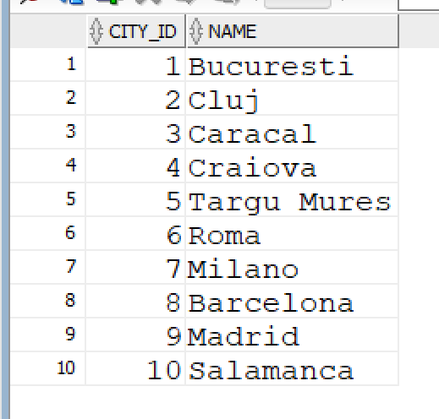

* Z_COUNTRIES

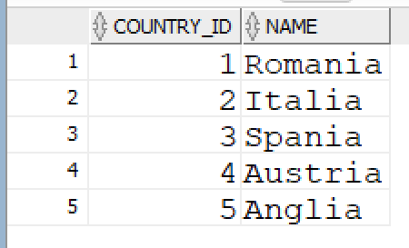

* Z_ADDRESSES

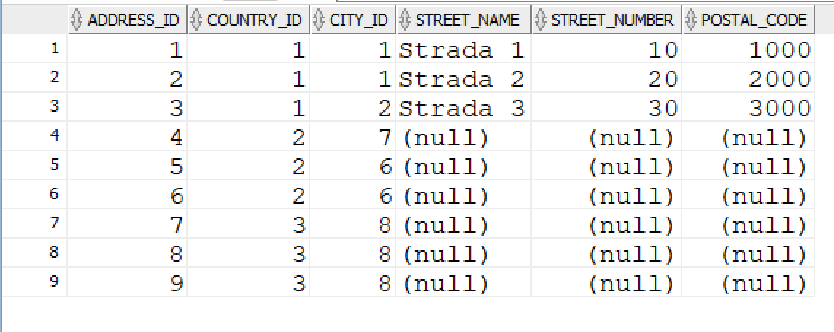

* Z_USERS

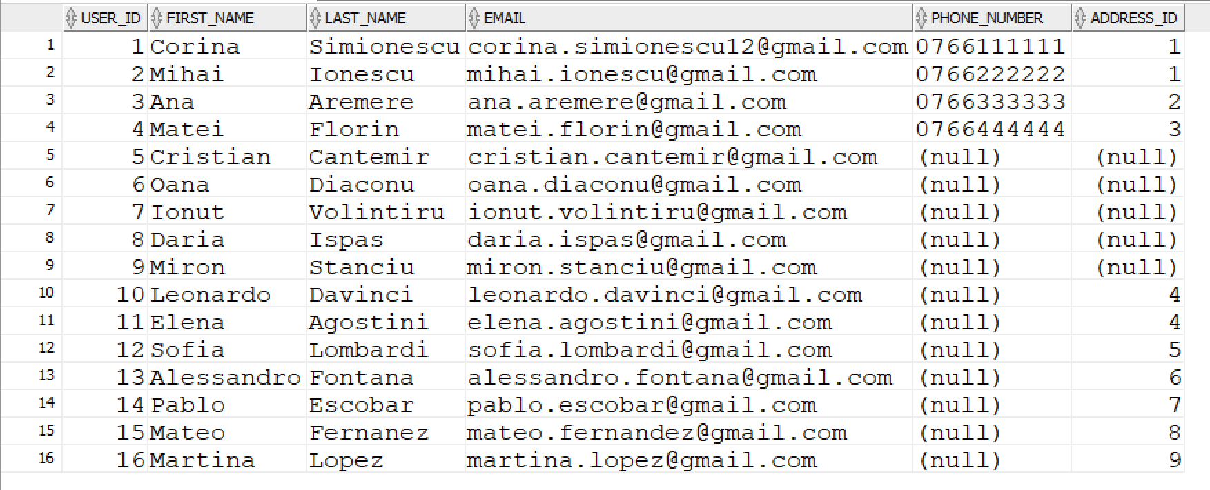

* Z_SHIPPING_METHODS

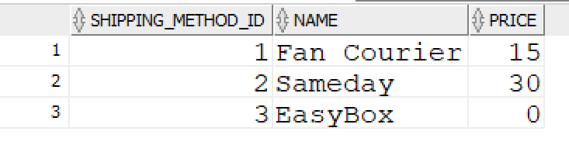

* Z_LAPTOP_BRANDS

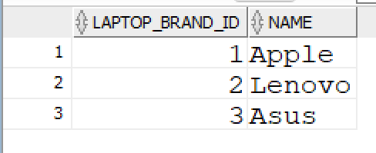

* Z_CPU_BRANDS

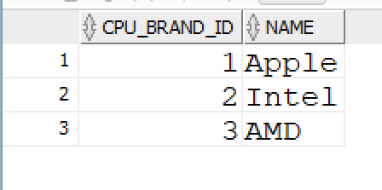

* Z_LAPTOPS

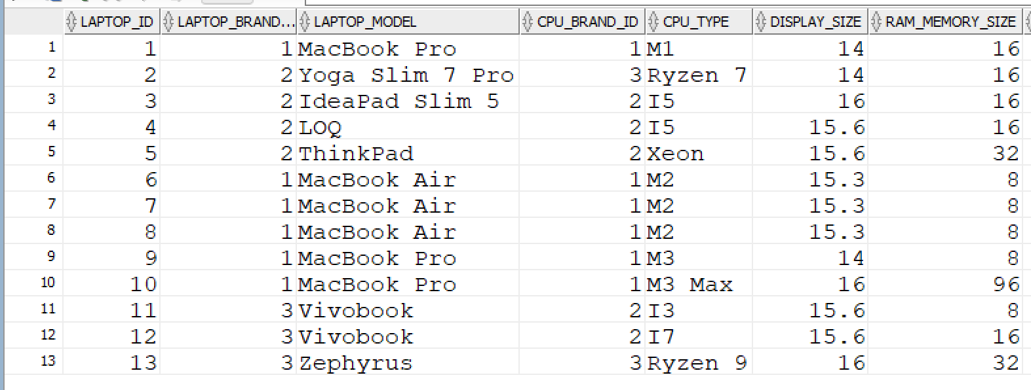 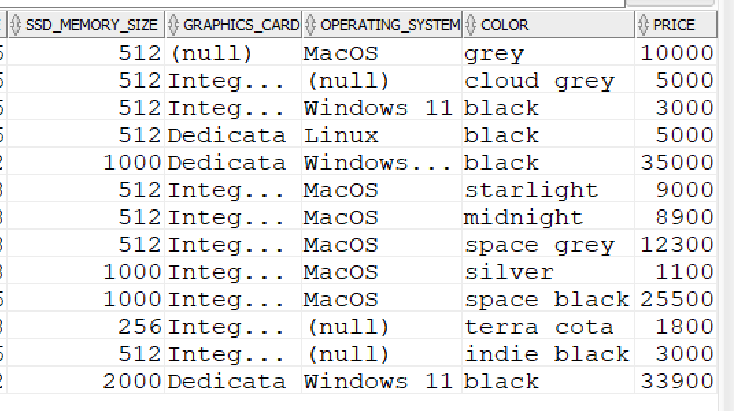

* Z_LAPTOP_ORDERS

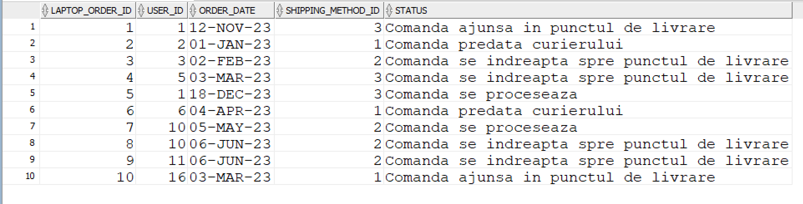

* Z_ORDER_LINES

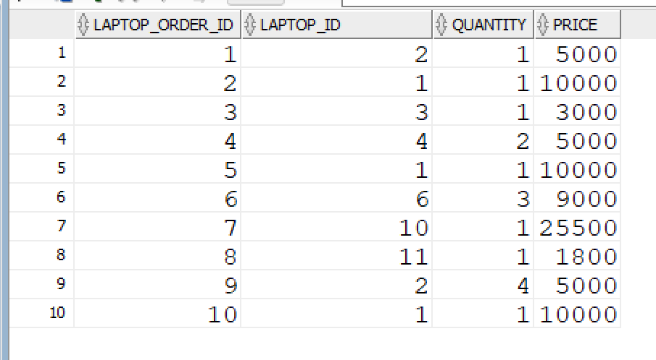

Pentru exemplificarea comenzilor UPDATE si DELETE am inserat un user in tabela Z_USERS:

INSERT INTO Z_USERS(USER_ID, FIRST_NAME, LAST_NAME, EMAIL)

VALUES (17, ‘Ion’, ‘Ionescu’, ‘ion.ionescu@gmail.com’);

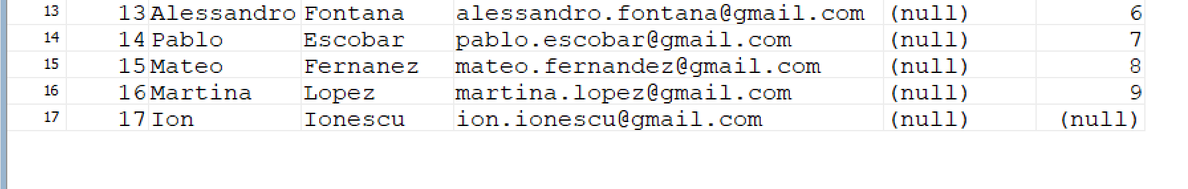

## **2. UPDATE**

-- Modificarea prenumeului in ‘George’ pentru userul cu id-ul = 17

UPDATE Z_USERS

SET FIRST_NAME = ‘George’

WHERE USER_ID = 17;

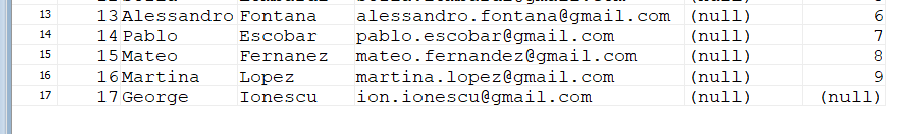

## **3. DELETE**

-- Stergerea userului cu id-ul = 17

DELETE FROM Z_USERS

WHERE USER_ID = 17;

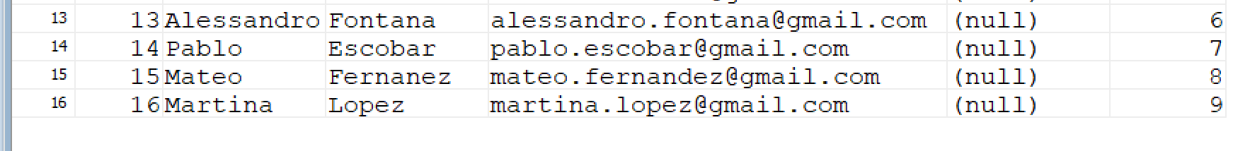

# **IMPLEMENTAREA INTEROGĂRILOR**

## **1. JONCȚIUNI**

### **1.1. INNER JOIN**

-- Afisare tara si orasul in care locuieste fiecare user

SELECT U.FIRST_NAME, U.LAST_NAME, CO.NAME AS COUNTRY, CI.NAME AS CITY

FROM Z_USERS U

JOIN Z_ADDRESSES A ON U.ADDRESS_ID = A.ADDRESS_ID

JOIN Z_COUNTRIES CO ON A.COUNTRY_ID = CO.COUNTRY_ID

JOIN Z_CITIES CI ON A.CITY_ID = CI.CITY_ID;

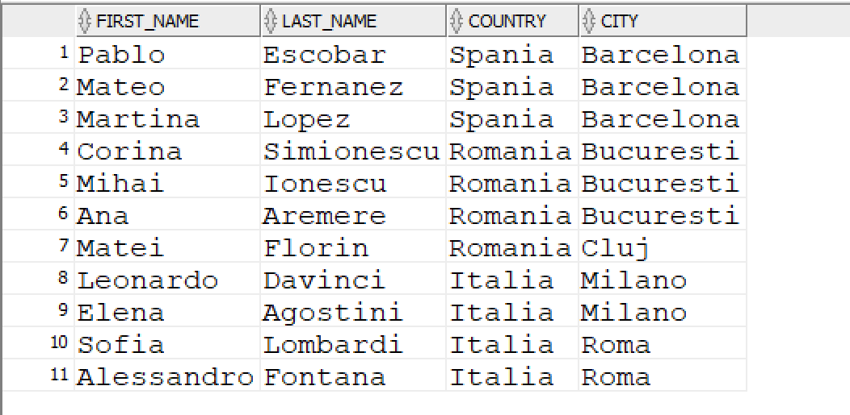

-- Afisare tara si orasul in care locuieste fiecare user care a comandat macar un laptop

SELECT U.FIRST_NAME, U.LAST_NAME, CO.NAME AS COUNTRY, CI.NAME AS CITY

FROM Z_USERS U

JOIN Z_ADDRESSES A ON U.ADDRESS_ID = A.ADDRESS_ID

JOIN Z_COUNTRIES CO ON A.COUNTRY_ID = CO.COUNTRY_ID

JOIN Z_CITIES CI ON A.CITY_ID = CI.CITY_ID

JOIN Z_LAPTOP_ORDERS LO ON U.USER_ID = LO.USER_ID

WHERE U.USER_ID = LO.USER_ID;

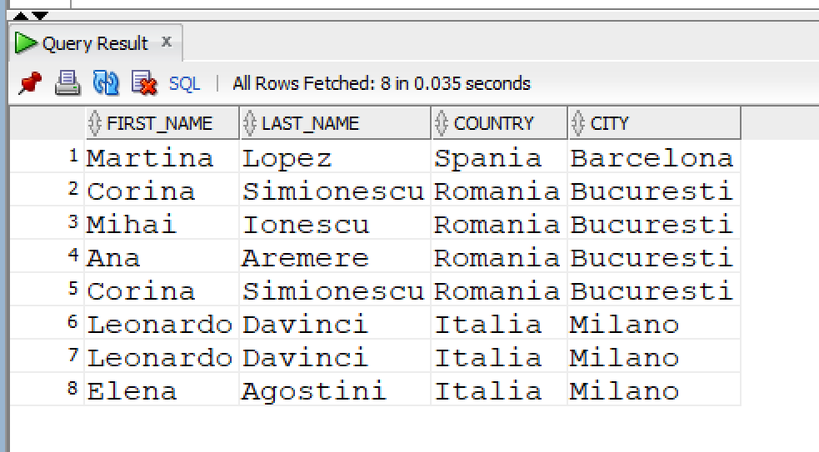

### **1.2. OUTER JOIN**

-- Selectarea tuturor userilor si a tarii in care locuiesc (daca au)

-- si selectarea tuturor tarilor indiferent daca au sau nu un user asociat

SELECT U.USER_ID, U.FIRST_NAME, CO.NAME AS COUNTRY_NAME

FROM Z_USERS U

LEFT JOIN Z_ADDRESSES A ON U.ADDRESS_ID = A.ADDRESS_ID

LEFT JOIN Z_COUNTRIES CO ON A.COUNTRY_ID = CO.COUNTRY_ID

UNION

SELECT USER_ID, FIRST_NAME, CO.NAME AS COUNTRY_NAME

FROM Z_COUNTRIES CO

LEFT JOIN Z_ADDRESSES A ON CO.COUNTRY_ID = A.COUNTRY_ID

LEFT JOIN Z_USERS U ON A.ADDRESS_ID = U.ADDRESS_ID;

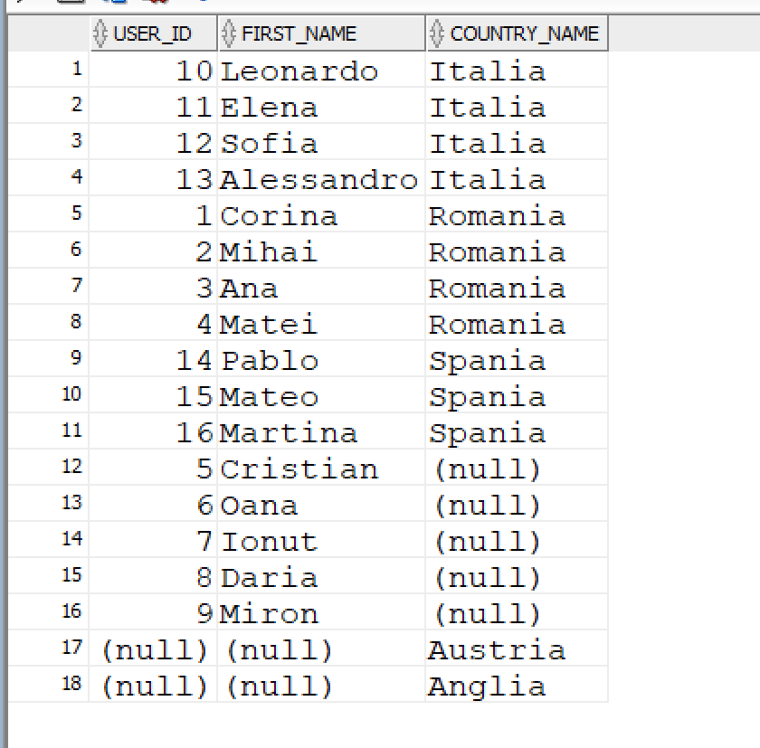

### **1.3. LEFT JOIN**

-- Afisare toti userii si numarul de laptopuri comandate

SELECT

U.USER_ID,

U.FIRST_NAME,

U.LAST_NAME,

U.EMAIL,

SUM(QUANTITY) AS NO_ORDERED_LAPTOPS

FROM Z_USERS U

LEFT JOIN Z_LAPTOP_ORDERS LO ON U.USER_ID = LO.USER_ID

LEFT JOIN Z_ORDER_LINES OL ON LO.LAPTOP_ORDER_ID = OL.LAPTOP_ORDER_ID

GROUP BY U.USER_ID, U.FIRST_NAME, U.LAST_NAME, U.EMAIL

ORDER BY U.USER_ID;

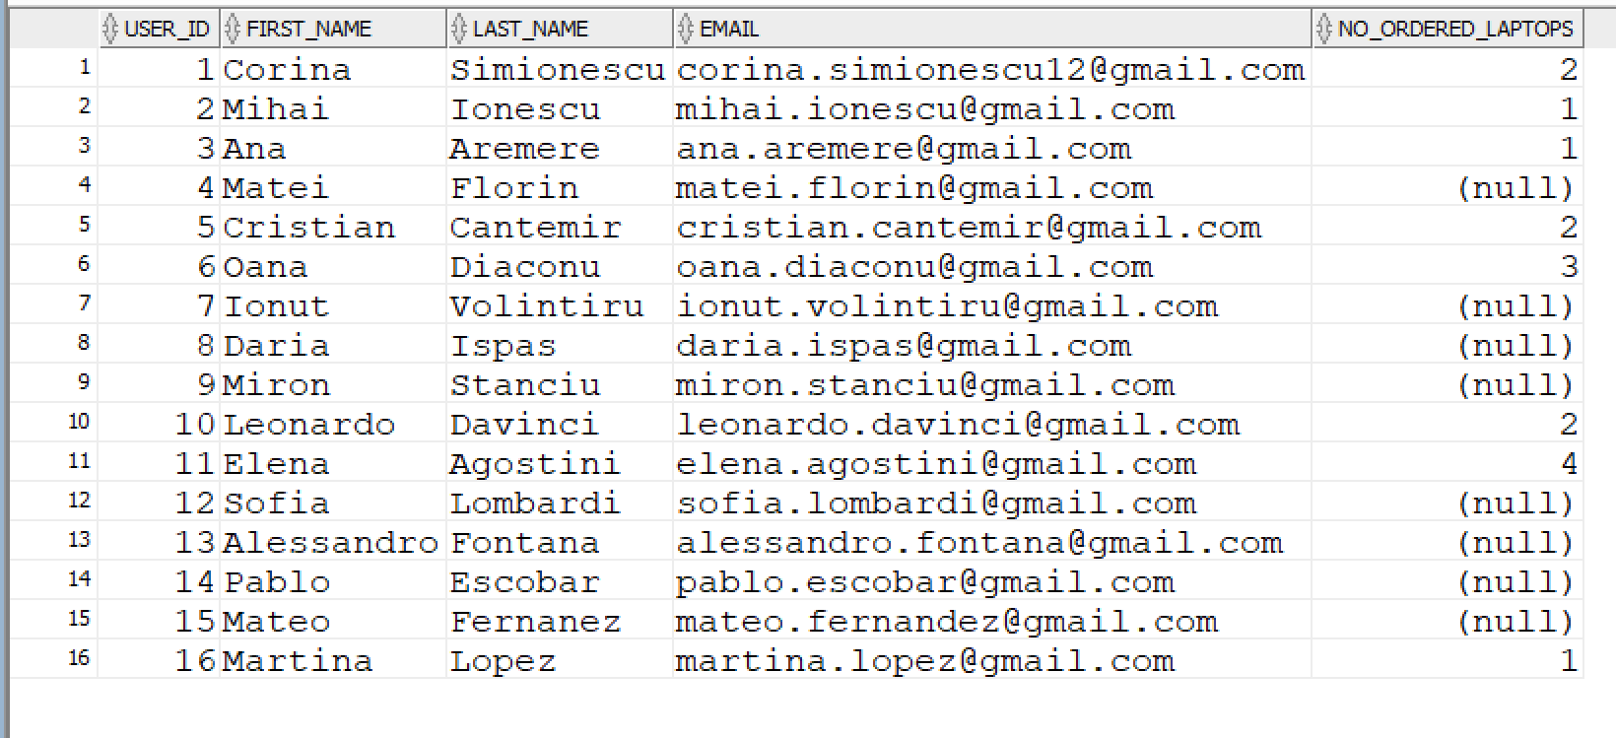

### **1.4. RIGHT JOIN**

-- Afisare toti userii care nu au dat comanda

SELECT U.USER_ID, U.FIRST_NAME, U.EMAIL, LO.LAPTOP_ORDER_ID

FROM Z_LAPTOP_ORDERS LO

RIGHT JOIN Z_USERS U ON LO.USER_ID = U.USER_ID

WHERE LAPTOP_ORDER_ID IS NULL;

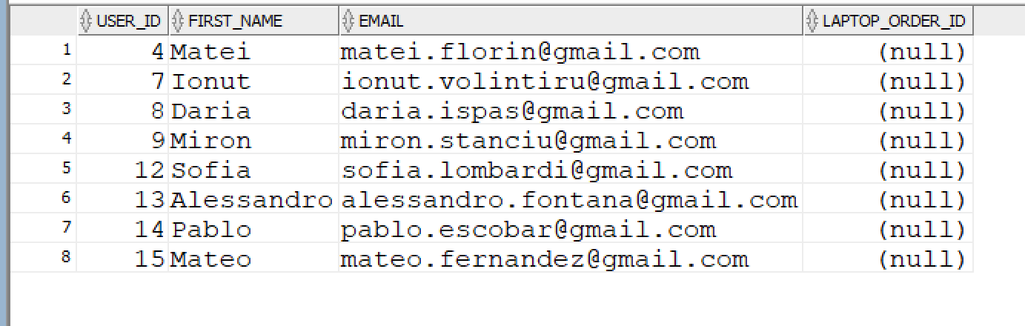

## **2. FUNCȚII DE GRUP**

### **2.1. COUNT**

-- Afisare toate laptopurile, de cate ori au fost comandate si cantitatea totala comandata

SELECT

L.LAPTOP_ID,

LB.NAME,

L.LAPTOP_MODEL,

COUNT(OL.LAPTOP_ID) AS NO_ORDERS,

SUM(OL.QUANTITY) AS ORDERED_QUANTITY

FROM Z_LAPTOPS L

JOIN Z_LAPTOP_BRANDS LB ON L.LAPTOP_BRAND_ID = LB.LAPTOP_BRAND_ID

LEFT JOIN Z_ORDER_LINES OL ON L.LAPTOP_ID = OL.LAPTOP_ID

GROUP BY L.LAPTOP_ID, LB.NAME, L.LAPTOP_MODEL

ORDER BY L.LAPTOP_ID ASC;

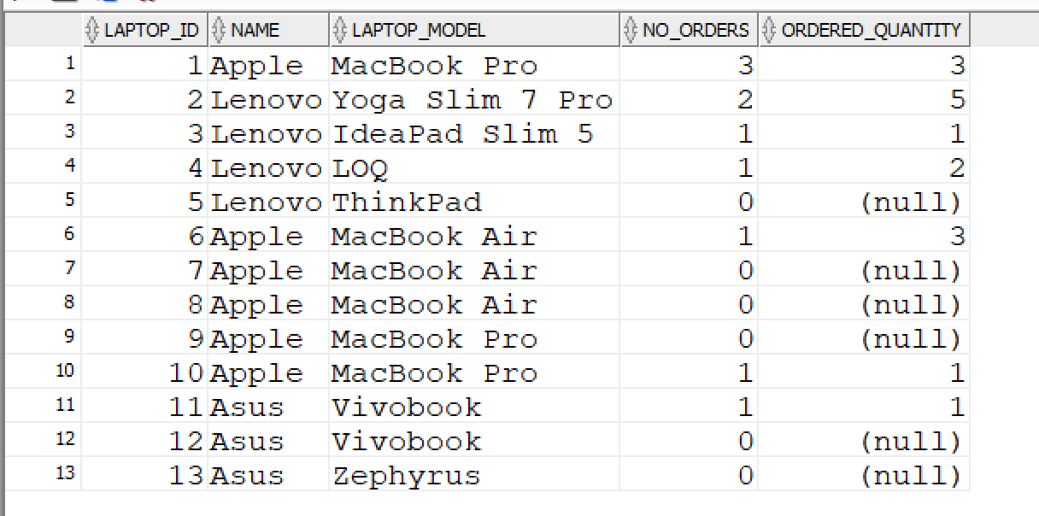

-- Afisare laptopuri care au fost comandate intre 1 si 3 ori

SELECT

L.LAPTOP_ID,

LB.NAME,

L.LAPTOP_MODEL,

COUNT(OL.LAPTOP_ID) AS NO_ORDERS

FROM Z_LAPTOPS L

JOIN Z_ORDER_LINES OL ON L.LAPTOP_ID = OL.LAPTOP_ID

JOIN Z_LAPTOP_BRANDS LB ON L.LAPTOP_BRAND_ID = LB.LAPTOP_BRAND_ID

HAVING COUNT(OL.LAPTOP_ID) BETWEEN 1 AND 3

GROUP BY L.LAPTOP_ID, LB.NAME, L.LAPTOP_MODEL;

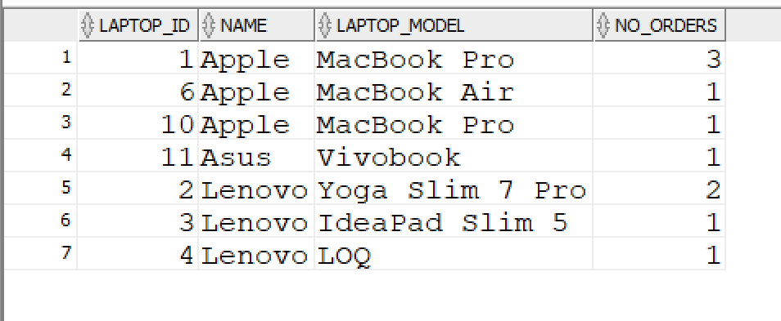

### **2.2. SUM**

-- Afisare tara cu cele mai multe laptopuri comandate

SELECT CO.NAME, SUM(OL.QUANTITY) AS ORDERED_QUANTITY

FROM Z_COUNTRIES CO

JOIN Z_ADDRESSES A ON CO.COUNTRY_ID = A.COUNTRY_ID

JOIN Z_USERS U ON A.ADDRESS_ID = U.ADDRESS_ID

JOIN Z_LAPTOP_ORDERS LO ON U.USER_ID = LO.USER_ID

JOIN Z_ORDER_LINES OL ON LO.LAPTOP_ORDER_ID = OL.LAPTOP_ORDER_ID

GROUP BY CO.NAME

ORDER BY SUM(OL.QUANTITY) DESC

FETCH FIRST 1 ROW ONLY;

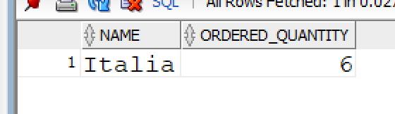

-- Afisare toti userii si numarul de laptopuri comandate

SELECT

U.USER_ID,

U.FIRST_NAME,

U.LAST_NAME,

U.EMAIL,

SUM(QUANTITY) AS NO_ORDERED_LAPTOPS

FROM Z_USERS U

LEFT JOIN Z_LAPTOP_ORDERS LO ON U.USER_ID = LO.USER_ID

LEFT JOIN Z_ORDER_LINES OL ON LO.LAPTOP_ORDER_ID = OL.LAPTOP_ORDER_ID

GROUP BY U.USER_ID, U.FIRST_NAME, U.LAST_NAME, U.EMAIL

ORDER BY U.USER_ID;



-- Afisare comenzile de peste 5000 de lei

SELECT LAPTOP_ORDER_ID, SUM(QUANTITY*PRICE)

FROM Z_ORDER_LINES

HAVING SUM(QUANTITY*PRICE) > 5000

GROUP BY LAPTOP_ORDER_ID;

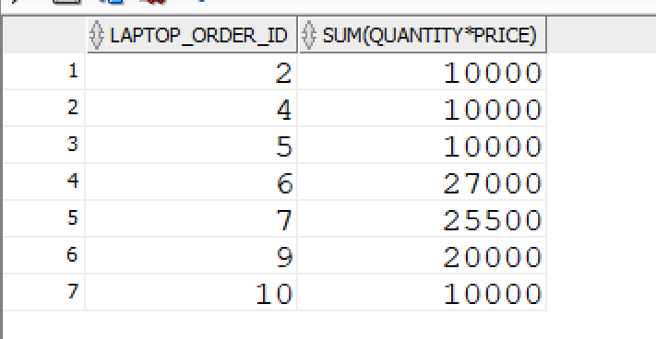

-- Afisare comenzi care au valoarea de 5000 de lei sau 10000 de lei

SELECT LAPTOP_ORDER_ID, SUM(QUANTITY*PRICE) AS ORDER_VALUE

FROM Z_ORDER_LINES

HAVING SUM(QUANTITY*PRICE) IN (5000, 10000)

GROUP BY LAPTOP_ORDER_ID;

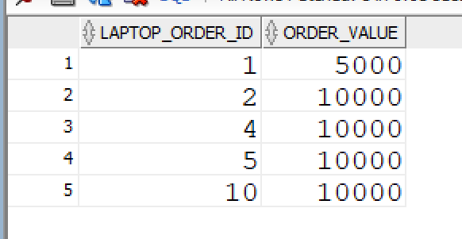

### **2.3. MIN**

--Afisare cel mai mic pret dintre preturile toate laptopurilor

SELECT MIN(PRICE) AS LOWEST_PRICE_FOR_A_LAPTOP

FROM Z_LAPTOPS;

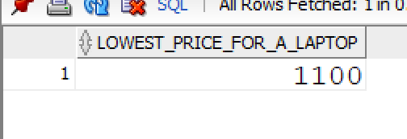

### **2.4. MAX**

-- Afisare cea mai mare cantitate de laptopuri comandate intr-o singura comanda

SELECT MAX(QUANTITY) AS HIGHEST_QUANITTY_ORDERED

FROM Z_ORDER_LINES;

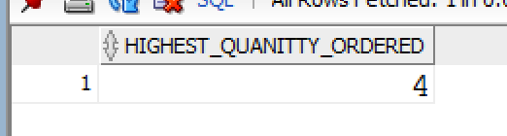

### **2.5. AVG**

-- Afisare pretul in medie pentru metoda de livrare

SELECT AVG(PRICE) AS AVERAGE_SHIPPING_PRICE

FROM Z_SHIPPING_METHODS;

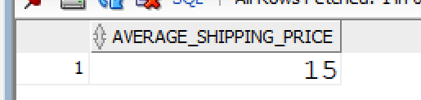

## **3. FUNCȚII SINGLE-ROW**

### **3.1. FUNCȚII NUMERICE**

#### **3.1.1. ROUND**

-- Afisare dimensiunea medie a displayului pentru fiecare brand de laptopuri

SELECT

LB.NAME,

ROUND(AVG(L.DISPLAY_SIZE), 2) AS AVERAGE_SIZE

FROM Z_LAPTOPS L

JOIN Z_LAPTOP_BRANDS LB ON L.LAPTOP_BRAND_ID = LB.LAPTOP_BRAND_ID

GROUP BY LB.NAME;

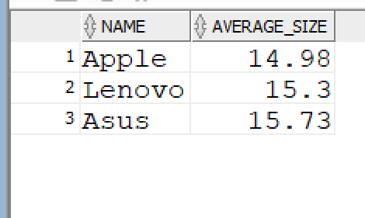

#### **3.1.2. TRUNC**

-- Afisare valoarea medie a comenzilor

SELECT TRUNC(AVG(ONE_ORDER_VALUE)) AS AVERAGE_ORDER_VALUE

FROM (SELECT LAPTOP_ORDER_ID, SUM(PRICE*QUANTITY) AS ONE_ORDER_VALUE

FROM Z_ORDER_LINES

GROUP BY LAPTOP_ORDER_ID);

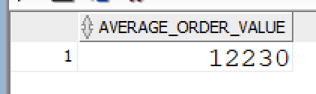

### **3.2. FUNCTII DE CARACTERE**

#### **3.2.1. LOWER**

-- Afisare cate laptopuri contin in numele culorii 'black' si pretul lor mediu

SELECT

COUNT(LAPTOP_ID) AS BLACK_LAPTOPS,

TRUNC(AVG(PRICE), 2) AS AVERGAGE_PRICE

FROM Z_LAPTOPS

WHERE LOWER(COLOR) LIKE '%black%';

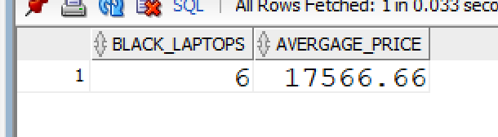

#### **3.2.2. UPPER**

-- Afisare cate comenzi au fost livrate de Fan Courier, valoarea comenzii (cu tot cu pretul

-- metodei de livrare si totalul userilor care au dat aceste comenzi

SELECT

COUNT(LO.LAPTOP_ORDER_ID) AS LAPTOPS_FANCOURIER,

COUNT(LO.USER_ID) AS USERS,

(SUM(OL.PRICE) + (COUNT(LO.LAPTOP_ORDER_ID) * SM.PRICE)) AS TOTAL_VALUE

FROM Z_LAPTOP_ORDERS LO

JOIN Z_SHIPPING_METHODS SM ON LO.SHIPPING_METHOD_ID = SM.SHIPPING_METHOD_ID

JOIN Z_ORDER_LINES OL ON LO.LAPTOP_ORDER_ID = OL.LAPTOP_ORDER_ID

WHERE UPPER(SM.NAME) LIKE 'FAN%COURIER'

GROUP BY SM.PRICE;

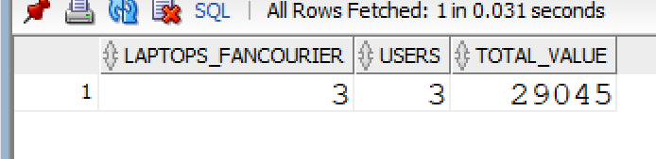

#### **3.2.3. INITCAP**

-- Afisare laptopuri al caror tip de procesor este 'Ryzen'. Pentru fiecare laptop

-- sa se afiseze si pretul, cantitatea in care a fost cumparat si profitul generat.

SELECT

L.LAPTOP_ID,

LB.NAME AS LAPTOP_BRAND,

L.LAPTOP_MODEL,

L.CPU_TYPE,

L.PRICE,

SUM(OL.QUANTITY) AS ORDERED_QUANTITY,

SUM(OL.PRICE*OL.QUANTITY) AS PROFIT

FROM Z_LAPTOPS L

JOIN Z_LAPTOP_BRANDS LB ON L.LAPTOP_BRAND_ID = LB.LAPTOP_BRAND_ID

LEFT JOIN Z_ORDER_LINES OL ON L.LAPTOP_ID = OL.LAPTOP_ID

WHERE INITCAP(CPU_TYPE) LIKE 'Ryzen%'

GROUP BY

L.LAPTOP_ID,

LB.NAME,

L.LAPTOP_MODEL,

L.CPU_TYPE,

L.PRICE;

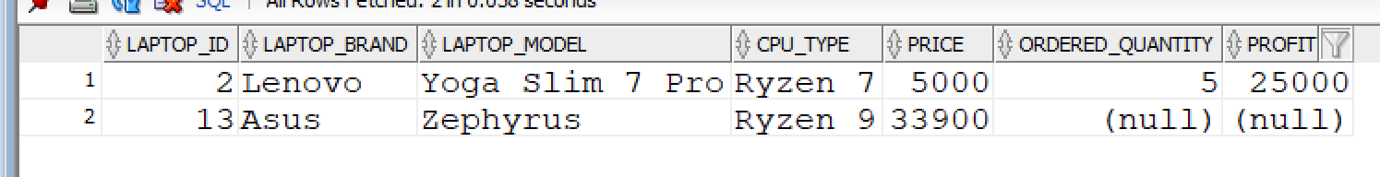

#### **3.2.4. OPERATORUL DE CONCATENARE: ||**

-- Pentru fiecare laptop sa se afiseze modelul si pretul folosind operatorul de concatenare

SELECT 'Laptopul: ' || LAPTOP_MODEL || ' are pretul de ' || PRICE || 'lei' LAPTOP_PRICE

FROM Z_LAPTOPS;

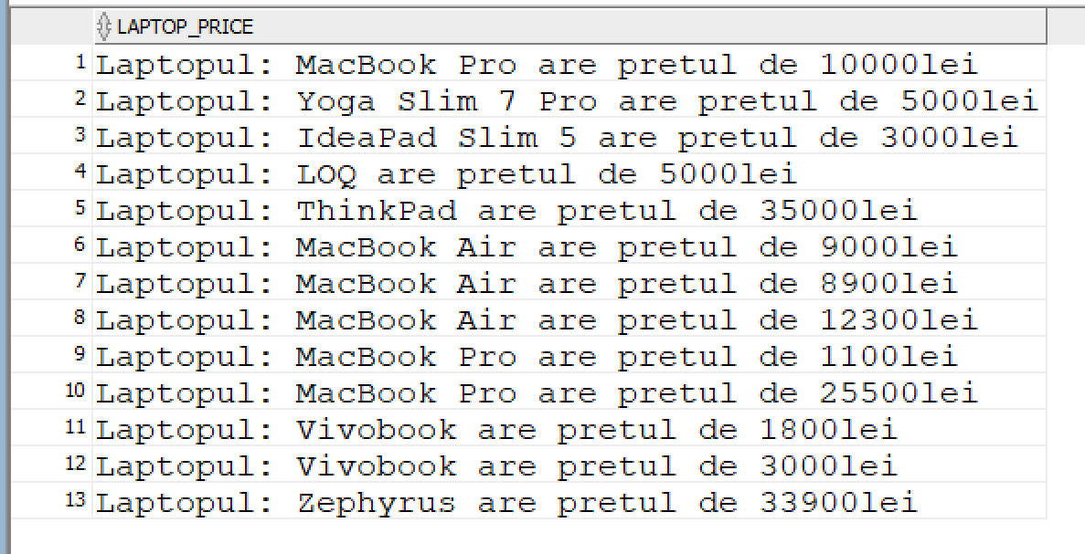

#### **3.2.5. SUBSTR**

-- Afisare cate laptopuri comandate au modelul MacBook si profitul adus de acestea

SELECT

SUM(OL.QUANTITY) AS TOTAL_QUANTITY_MACBOOK,

SUM(OL.PRICE) AS PROFIT

FROM Z_ORDER_LINES OL

JOIN Z_LAPTOPS L ON OL.LAPTOP_ID = L.LAPTOP_ID

WHERE LOWER(SUBSTR(L.LAPTOP_MODEL, 1, 7)) = 'macbook';

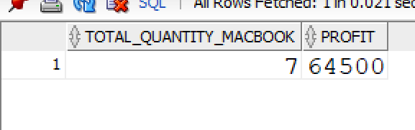

#### **3.2.6. CONCAT SI LENGTH**

-- Afisare user id, numele de familie, numarul de telefon concatenat cu primele 2 litere din

-- numele tarii, lungimea numarului de telefon

SELECT

U.USER_ID,

U.LAST_NAME,

CONCAT(U.PHONE_NUMBER, SUBSTR(CO.NAME,1,2)) AS PHONE_COUNTRY,

LENGTH(PHONE_NUMBER)

FROM Z_USERS U

JOIN Z_ADDRESSES A ON U.ADDRESS_ID = A.ADDRESS_ID

JOIN Z_COUNTRIES CO ON A.COUNTRY_ID = CO.COUNTRY_ID;

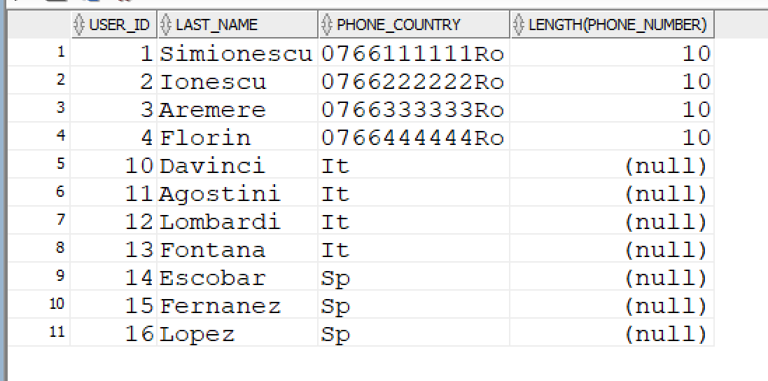

### **3.3. FUNCȚII DE TIP DATĂ CALENDARISTICĂ**

#### **3.3.1. SYSDATE**

-- Afisare zilele dintre ultima comanda plasata si ziua de azi

SELECT ROUND(SYSDATE - ORDER_DATE) AS DAYS

FROM Z_LAPTOP_ORDERS

WHERE ORDER_DATE = (SELECT ORDER_DATE

FROM Z_LAPTOP_ORDERS

ORDER BY ORDER_DATE DESC

FETCH FIRST 1 ROW ONLY);

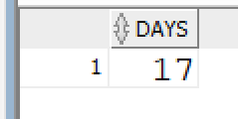

#### **3.3.2. MONTH_BETWEEN() , NEXT_DAY() , LAST_DAY(), ADD_MONTHS()**

-- Afisare idul comenzii, data in care a fost plasata comanda, numarul de luni intre

-- data de azi si data plasarii comenzii, urmatoarea zi de luni dupa data plasarii,

-- ultima zi din luna din care face parte data plasarii si data corespunzatoare dupa 10

-- luni de la data plasarii comenzii

SELECT

LAPTOP_ORDER_ID,

ORDER_DATE,

ROUND(MONTHS_BETWEEN(SYSDATE, ORDER_DATE)) AS MONTHS,

NEXT_DAY(ORDER_DATE, 'MONDAY') AS NEXT_MONDAY,

LAST_DAY(ORDER_DATE) AS LAST_DAY_FROM_MONTH,

ADD_MONTHS(ORDER_DATE, 10) AS DATE_AFTER_10_MONTHS

FROM Z_LAPTOP_ORDERS;

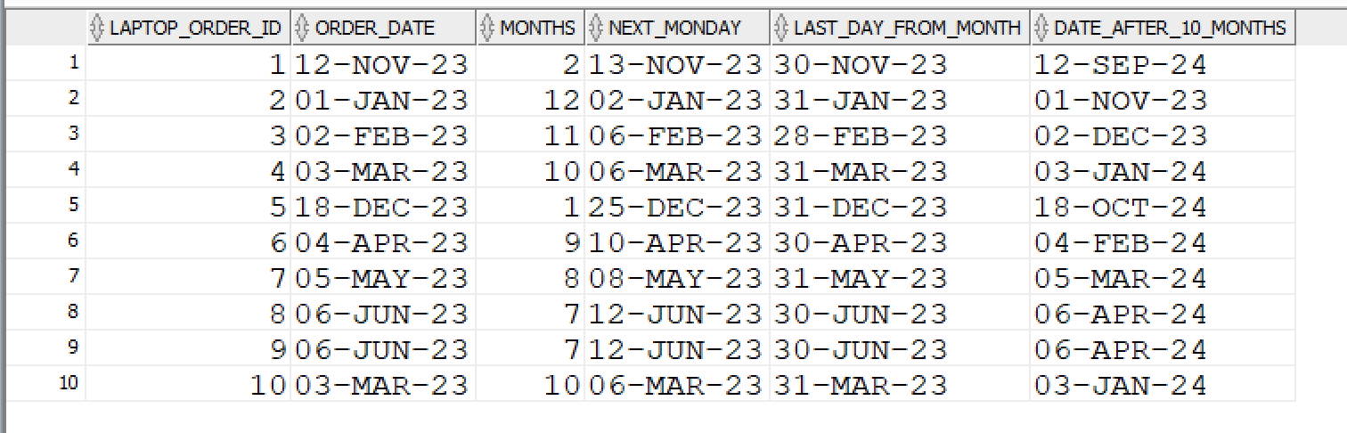

## **4. REALIZAREA INTEROGĂRILOR PE BAZA UNOR CONDIȚII**

### **4.1. DECODE**

-- Categorisirea laptopurilor in functie de marimea display-ului.

-- dimensiune display < 15.3, atunci laptopul intrain categoria 'Mic'

-- dimensiune dispkay = 15.3, categorie 'Mediu'

-- dimensiune display > 15.3, categorie 'Mare'

SELECT

LAPTOP_ID,

LAPTOP_MODEL,

DISPLAY_SIZE,

DECODE(

SIGN(DISPLAY_SIZE - 15.3),

-1, 'Small',

0, 'Medium',

1, 'Large'

) AS DISPLAY_CATEGORY

FROM

Z_LAPTOPS;

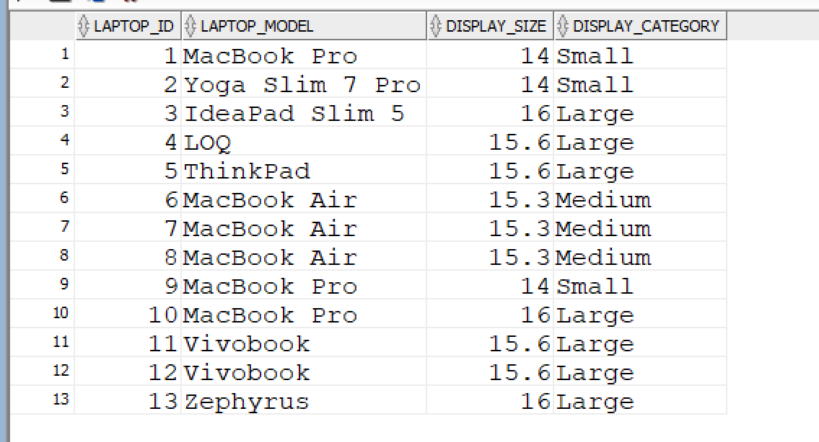

### **4.2. CASE**

-- Categorisirea laptopurilor in functie de dimensiunea memoriei de tip SSD

SELECT

LAPTOP_ID,

LAPTOP_MODEL,

SSD_MEMORY_SIZE,

CASE

WHEN SSD_MEMORY_SIZE <= 256 THEN 'Small'

WHEN SSD_MEMORY_SIZE >= 512 AND SSD_MEMORY_SIZE <= 512 THEN 'Medium'

WHEN SSD_MEMORY_SIZE >= 1000 THEN 'Large'

ELSE 'Unknown'

END AS SSD_MEMORY_CATEGORY

FROM

Z_LAPTOPS;

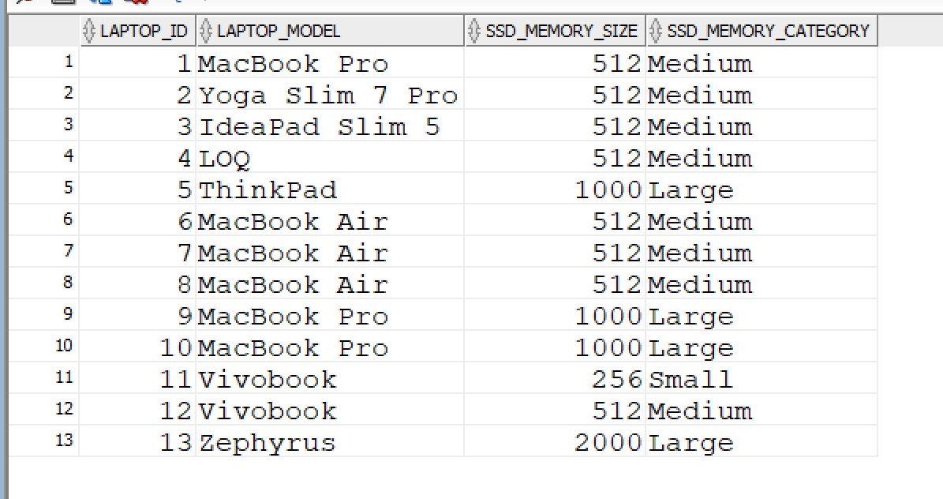

## **5. OPERATORII ALGEBREI RELAȚIONALE**

### **5.1. MINUS**

-- Selectarea userilor care nu au o tara

SELECT U.USER_ID, U.FIRST_NAME, CO.NAME AS COUNTRY_NAME

FROM Z_USERS U

LEFT JOIN Z_ADDRESSES A ON U.ADDRESS_ID = A.ADDRESS_ID

LEFT JOIN Z_COUNTRIES CO ON A.COUNTRY_ID = CO.COUNTRY_ID

MINUS

SELECT USER_ID, FIRST_NAME, CO.NAME AS COUNTRY_NAME

FROM Z_COUNTRIES CO

JOIN Z_ADDRESSES A ON CO.COUNTRY_ID = A.COUNTRY_ID

JOIN Z_USERS U ON A.ADDRESS_ID = U.ADDRESS_ID;

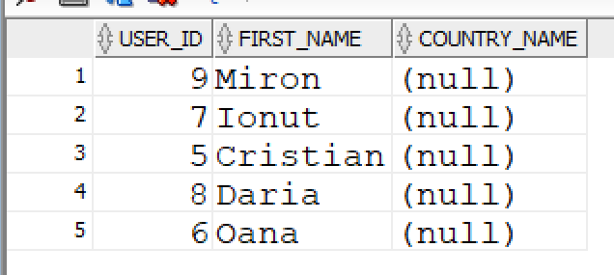

### **5.2. INTERSECT**

-- Selectarea userilor cu id-ul cuprins intre 1 si 4 si al caror prenume incepe cu litera M

SELECT USER_ID, FIRST_NAME

FROM Z_USERS

WHERE USER_ID BETWEEN 1 AND 4

INTERSECT

SELECT USER_ID, FIRST_NAME

FROM Z_USERS

WHERE FIRST_NAME LIKE 'M%';

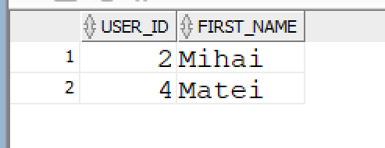

### **5.3. UNION**

-- Selectarea userilor din Romania si a celor din Italia, utilizand UNION

SELECT U.USER_ID, U.FIRST_NAME, U.LAST_NAME, CO.NAME

FROM Z_USERS U

JOIN Z_ADDRESSES A ON U.ADDRESS_ID = A.ADDRESS_ID

JOIN Z_COUNTRIES CO ON A.COUNTRY_ID = CO.COUNTRY_ID

WHERE UPPER(CO.NAME) = 'ROMANIA'

UNION

SELECT U.USER_ID, U.FIRST_NAME, U.LAST_NAME, CO.NAME

FROM Z_USERS U

JOIN Z_ADDRESSES A ON U.ADDRESS_ID = A.ADDRESS_ID

JOIN Z_COUNTRIES CO ON A.COUNTRY_ID = CO.COUNTRY_ID

WHERE UPPER(CO.NAME) = 'ITALIA';

## **6. SUBCERERI**

-- Afisare cel mai scump laptop si cantitatea in care a fost cumparat

SELECT

L.LAPTOP_ID,

LB.NAME AS BRAND_NAME,

L.LAPTOP_MODEL,

L.PRICE,

OL.QUANTITY

FROM Z_LAPTOPS L

JOIN Z_LAPTOP_BRANDS LB ON L.LAPTOP_BRAND_ID = LB.LAPTOP_BRAND_ID

LEFT JOIN Z_ORDER_LINES OL ON L.LAPTOP_ID = OL.LAPTOP_ID

WHERE L.PRICE = (SELECT MAX(PRICE) FROM Z_LAPTOPS);

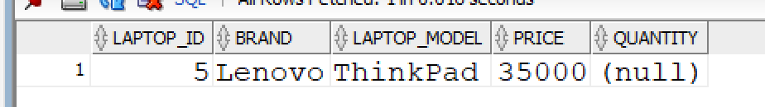

-- Afisare laptopul care a generat cele mai multe vanzari

SELECT

L.LAPTOP_ID,

LB.NAME AS BRAND,

L.LAPTOP_MODEL,

SUM(OL.QUANTITY*OL.PRICE) AS GENERATED_SALES_VALUE

FROM Z_LAPTOPS L

JOIN Z_LAPTOP_BRANDS LB ON L.LAPTOP_BRAND_ID = LB.LAPTOP_BRAND_ID

JOIN Z_ORDER_LINES OL ON L.LAPTOP_ID = OL.LAPTOP_ID

WHERE L.LAPTOP_ID =(SELECT LAPTOP_ID

FROM Z_ORDER_LINES

GROUP BY LAPTOP_ID

ORDER BY SUM(QUANTITY*PRICE) DESC

FETCH FIRST 1 ROW ONLY)

GROUP BY L.LAPTOP_ID, LB.NAME, L.LAPTOP_MODEL;

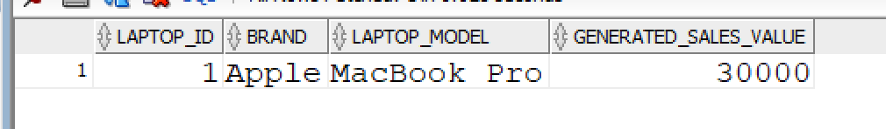

-- Afisare toate laptopurile care au un pret mai mare ca pretul mediu per laptop si cantitatea

-- vanduta pentru fiecare

SELECT OL.QUANTITY AS SOLD_QUANTITY, L.*

FROM Z_LAPTOPS L

LEFT JOIN Z_ORDER_LINES OL ON L.LAPTOP_ID = OL.LAPTOP_ID

WHERE L.PRICE > (SELECT AVG(LA.PRICE) FROM Z_LAPTOPS LA);

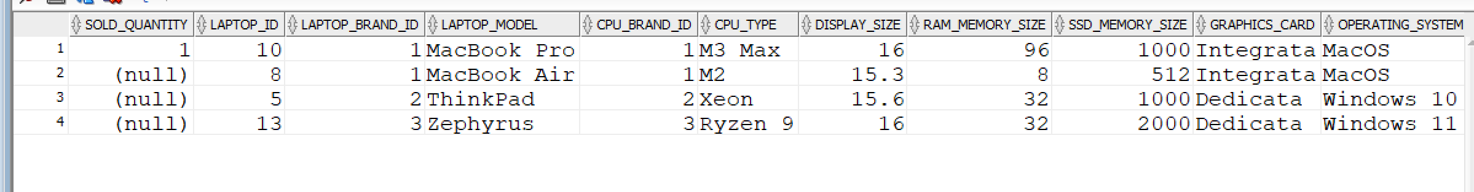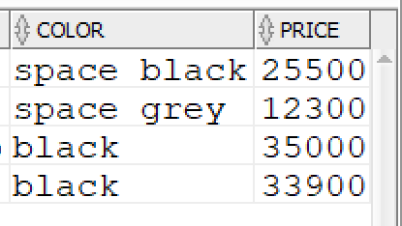

-- Afisare laptopuri care au un pret mai mare fata de pretul mediu al laptopurilor

-- cu acelasi brand

SELECT L.LAPTOP_ID, L.LAPTOP_BRAND_ID, L.LAPTOP_MODEL, L.PRICE

FROM Z_LAPTOPS L

WHERE L.PRICE > (SELECT AVG(LB.PRICE)

FROM Z_LAPTOPS LB

WHERE LB.LAPTOP_BRAND_ID = L.LAPTOP_BRAND_ID);

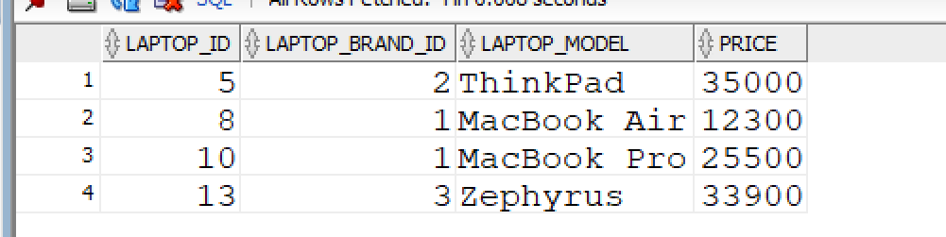

-- Afisare toti userii si cati bani au dat pe laptopuri, dar si pe livrare

SELECT

U.USER_ID,

U.FIRST_NAME,

U.LAST_NAME,

(SELECT SUM(OL.PRICE * OL.QUANTITY)

FROM Z_ORDER_LINES OL

JOIN Z_LAPTOP_ORDERS LO ON OL.LAPTOP_ORDER_ID = LO.LAPTOP_ORDER_ID

WHERE LO.USER_ID = U.USER_ID) AS AMOUNT_SPENT_ON_LAPTOPS,

(SELECT SUM(SM.PRICE)

FROM Z_SHIPPING_METHODS SM

JOIN Z_LAPTOP_ORDERS LO ON SM.SHIPPING_METHOD_ID = LO.SHIPPING_METHOD_ID

WHERE LO.USER_ID = U.USER_ID) AS AMOUNT_SPENT_ON_SHIPPING

FROM Z_USERS U

ORDER BY U.USER_ID ASC;

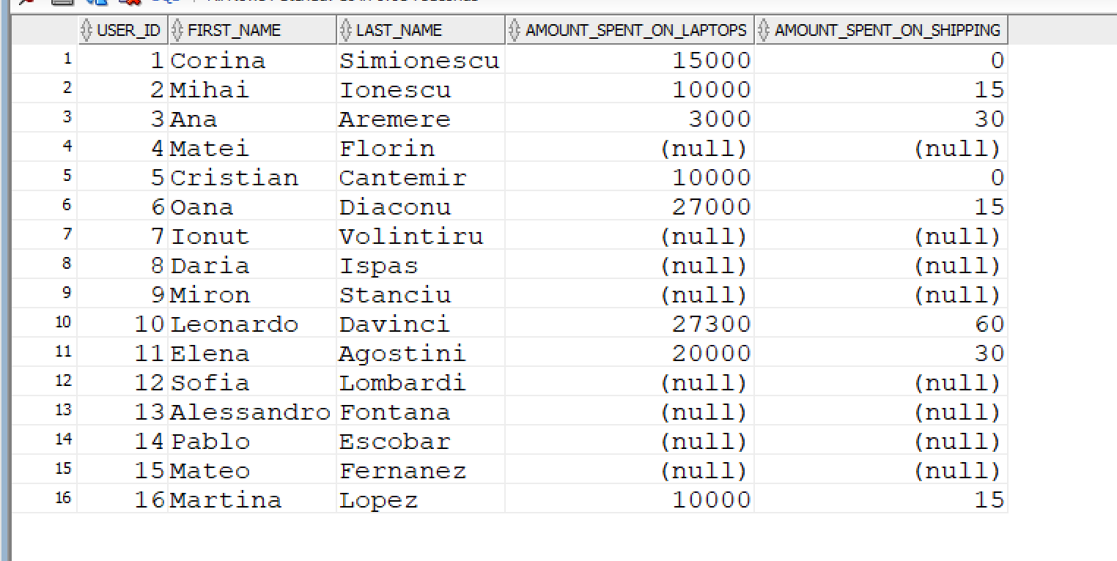

# **GESTIUNEA ALTOR OBIECTE ALE BAZEI DE DATE**

## **1. TABELE VIRTUALE**

### **1.1. CREARE TABELĂ VIRTUALĂ**

-- Crearea unei tabele virtuale cu urmatoarele coloane:

-- id-ul comenzii,id-ul userului, pretul total al laptopurilor din comanda,

-- pretul metodei de livrare si pretul total

CREATE OR REPLACE VIEW ORDERS_PRICES_DETAILS AS

SELECT

OL.LAPTOP_ORDER_ID,

LO.USER_ID,

SUM(OL.PRICE*OL.QUANTITY) AS LAPTOPS_PRICE,

SM.PRICE AS SHIPPING_PRICE,

SUM(OL.PRICE*OL.QUANTITY) + SM.PRICE AS TOTAL_PRICE

FROM Z_LAPTOP_ORDERS LO

JOIN Z_ORDER_LINES OL ON LO.LAPTOP_ORDER_ID = OL.LAPTOP_ORDER_ID

JOIN Z_SHIPPING_METHODS SM ON LO.SHIPPING_METHOD_ID = SM.SHIPPING_METHOD_ID

GROUP BY

OL.LAPTOP_ORDER_ID,

LO.USER_ID,

SM.PRICE

ORDER BY LAPTOP_ORDER_ID;

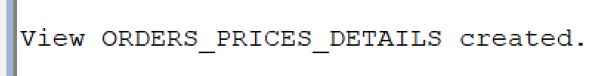

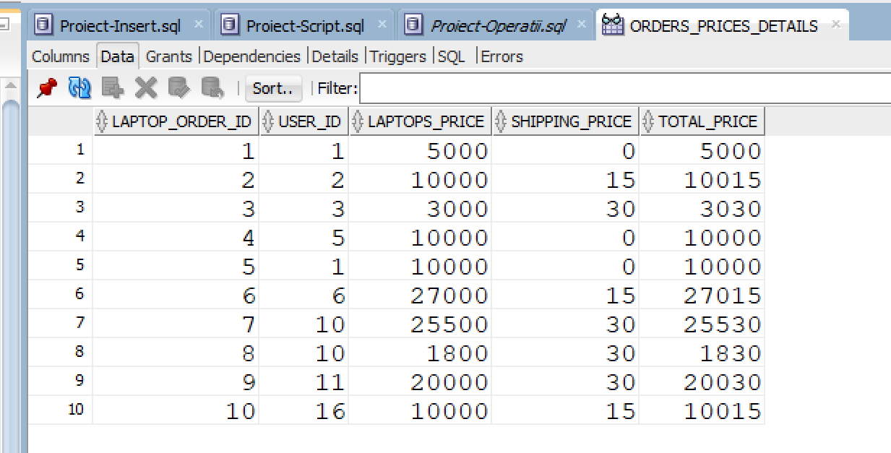

-- Crearea unei tabele virtuale cu urmatoarele coloane:

-- id user, nume, prenume, tara si orasul din adresa

CREATE OR REPLACE VIEW USERS_COUNTRY_CITY AS

SELECT

U.USER_ID,

U.FIRST_NAME,

U.LAST_NAME,

CO.NAME AS COUNTRY,

CI.NAME AS CITY

FROM Z_USERS U

LEFT JOIN Z_ADDRESSES A ON U.ADDRESS_ID = A.ADDRESS_ID

LEFT JOIN Z_COUNTRIES CO ON A.COUNTRY_ID = CO.COUNTRY_ID

LEFT JOIN Z_CITIES CI ON A.CITY_ID = CI.CITY_ID

ORDER BY U.USER_ID ASC;

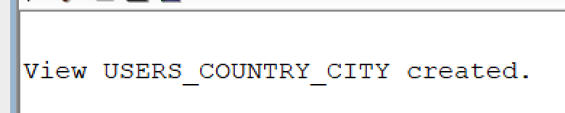

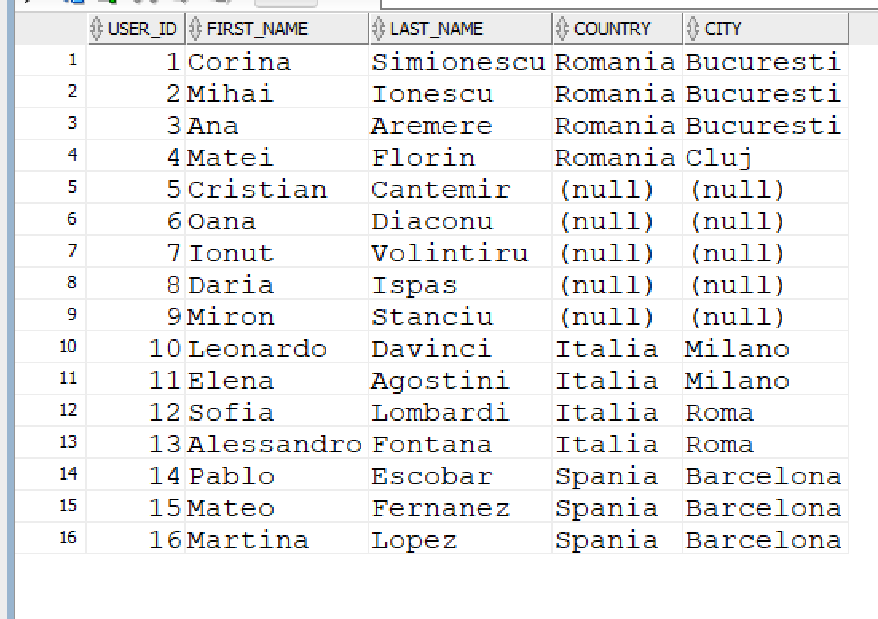

### **1.2. INTEROGARE TABELĂ VIRTUALĂ**

-- Afisare toti userii pt care suma totala a comenzilor este mai mare de 10000 de lei

SELECT *

FROM ORDERS_PRICES_DETAILS

WHERE TOTAL_PRICE >= 10000

ORDER BY LAPTOP_ORDER_ID;

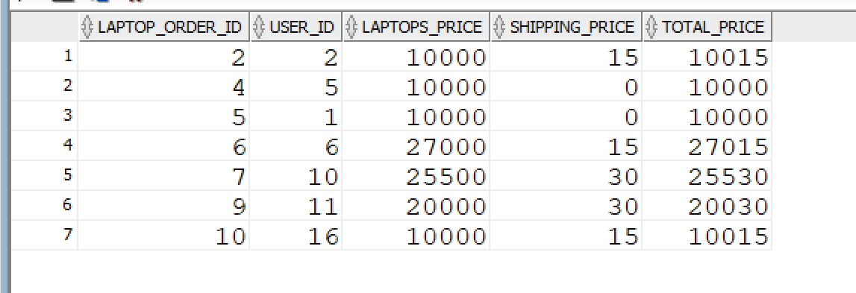

### **1.3. STERGERE TABELĂ VIRTUALĂ**

DROP VIEW ORDERS_PRICES_DETAILS;

DROP VIEW USERS_COUNTRY_CITY;

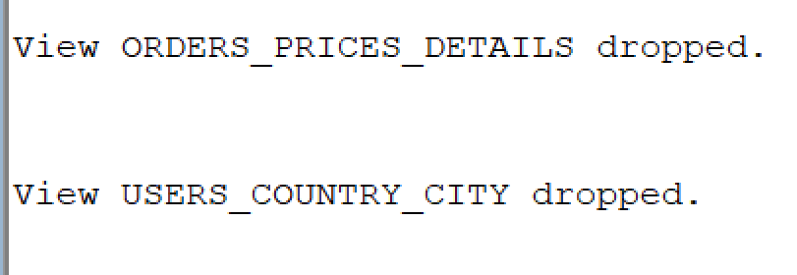

## **2. INDECȘI**

### **2.1. CREARE INDEX**

-- Creare index pentru coloana "price" din tabelul Z_ORDER_LINES

CREATE INDEX IDX_ORDER_LINES_PRICE ON Z_ORDER_LINES(PRICE);

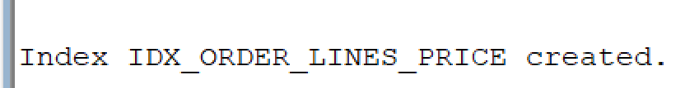

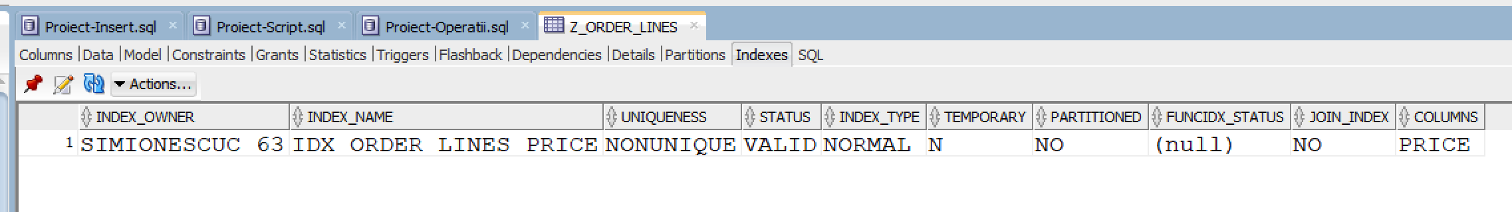

-- Creare index pentru coloana "quantity" din tabelul Z_ORDER_LINES

CREATE INDEX IDX_ORDER_LINES_QUANTITY ON Z_ORDER_LINES(QUANTITY);

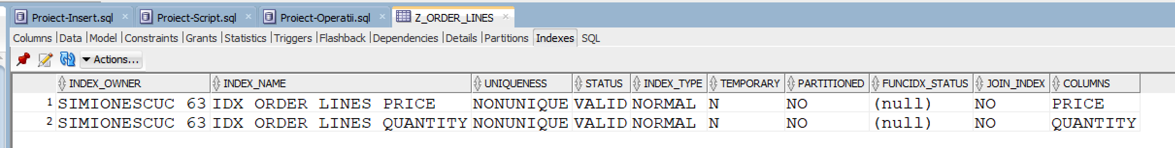

### **2.2. VIZUALIZARE INDECȘI**

SELECT * FROM USER_INDEXES;

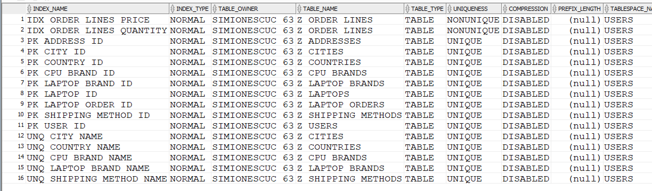

### **2.3. EFICIENTA INDECȘILOR**

-- Afisare useri si valoarea laptopurilor comandate daca pretul >= 10000 si cantitatea >= 1

SELECT

U.USER_ID,

U.FIRST_NAME,

U.LAST_NAME,

SUM(OL.PRICE*OL.QUANTITY)

FROM Z_ORDER_LINES OL

JOIN Z_LAPTOP_ORDERS LO ON OL.LAPTOP_ORDER_ID = LO.LAPTOP_ORDER_ID

JOIN Z_USERS U ON LO.USER_ID = U.USER_ID

WHERE

OL.PRICE >= 10000

AND

OL.QUANTITY >= 1

GROUP BY

U.USER_ID,

U.FIRST_NAME,

U.LAST_NAME;

**Costul de execuție inainte de crearea indecșilor:**

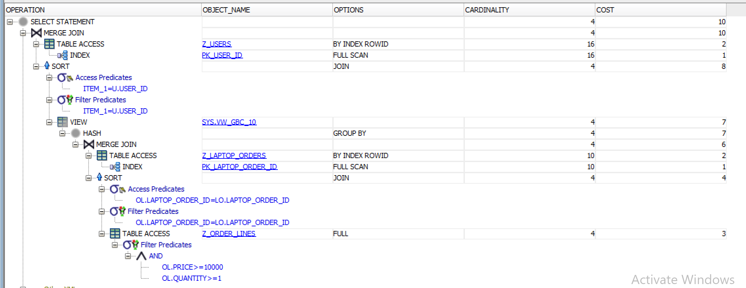

**Costul de execuție după de crearea indecșilor:**

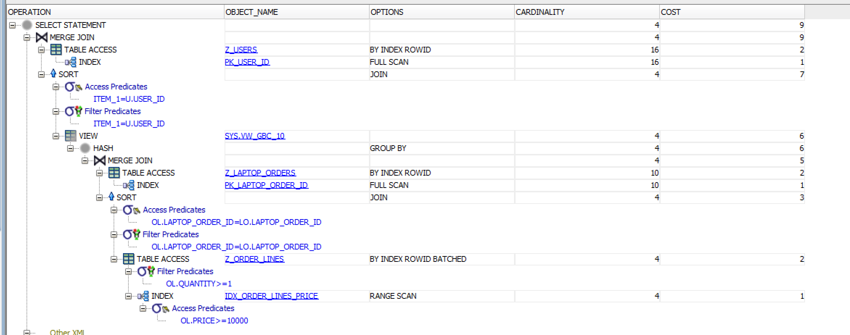

### **2.4. STERGERE INDECȘI**

DROP INDEX IDX_ORDER_LINES_PRICE;

DROP INDEX IDX_ORDER_LINES_QUANTITY;

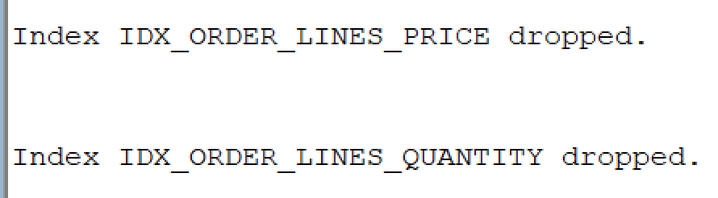

## **3. SINONIME**

### **3.1. CREARE SINONIM**

-- Creare sinonim privat pentru tabela Z_SHIPPING_METHODS

CREATE OR REPLACE SYNONYM SM FOR Z_SHIPPING_METHODS;

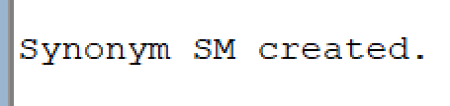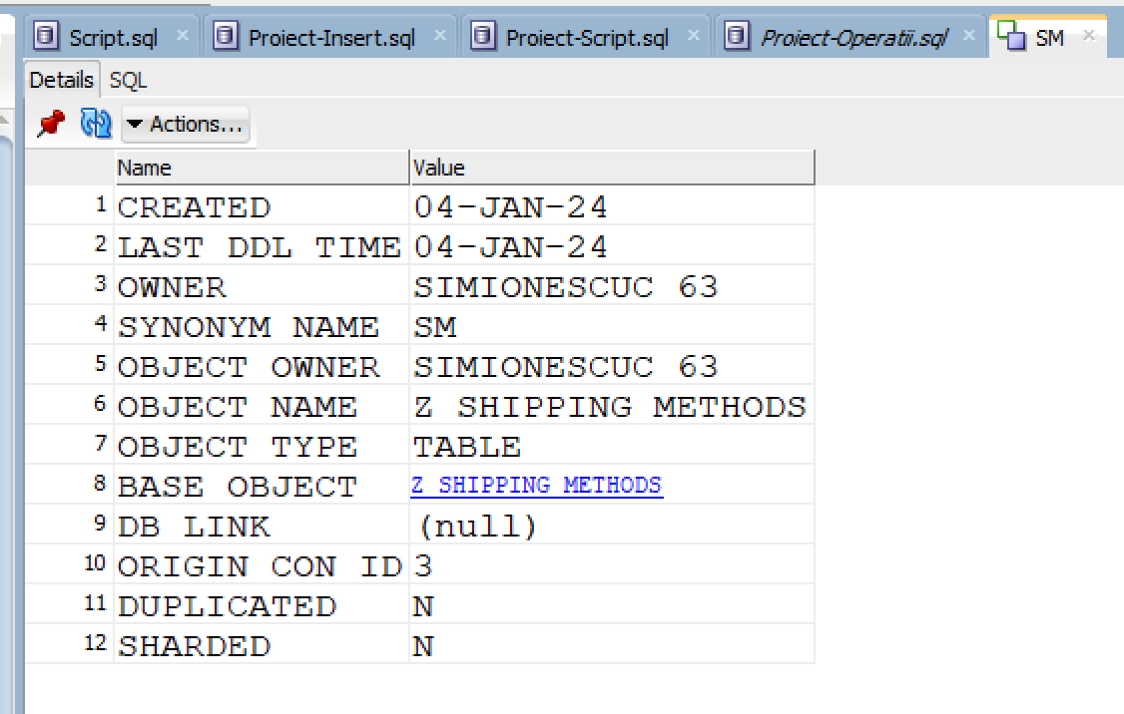

### **3.2. UTILIZAREA SINONIMULUI CREAT**

-- Afisare metode de livrare, folodind sinonimul creat anterior

SELECT * FROM SM;

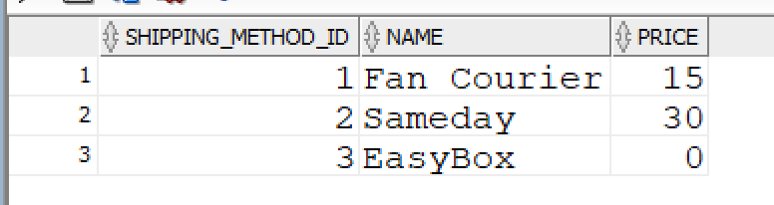

### **3.3. VIZUALIZARE SINONIME**

SELECT * FROM USER_SYNONYMS;

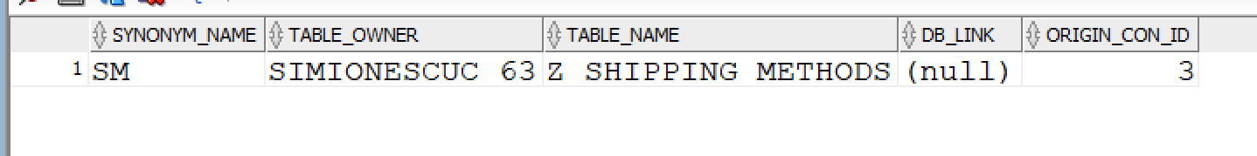

### **3.4. STERGERE SINONIM**

DROP SYNONYM SM;

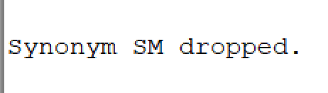

## **4. SECVENȚE**

### **4.1. CREARE SECVENȚĂ**

-- Crearea unei secvente pentru asigurarea unicitatii cheii primare din tabela

-- Z_USERS

CREATE SEQUENCE SEQ_NR_USER

START WITH 100 INCREMENT BY 1

MAXVALUE 1000 NOCYCLE;

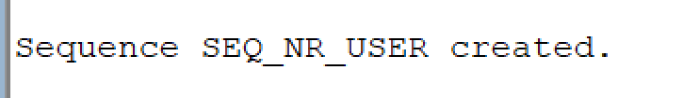

### **4.2. UTILIZAREA SECVENȚEI CREATE**

-- Sa se insereze 2 useri in tabela Z_USERS, folosind secventa creata anterior

INSERT INTO Z_USERS (USER_ID, FIRST_NAME, LAST_NAME, EMAIL)

VALUES(SEQ_NR_USER.NEXTVAL, 'Celmaitareprenume', 'Numesmecher', 'alabala@gmail.com');

INSERT INTO Z_USERS (USER_ID, FIRST_NAME, LAST_NAME, EMAIL)

VALUES(SEQ_NR_USER.NEXTVAL, 'Celmaiprostprenume', 'Numenaspa', 'portocala@gmail.com');

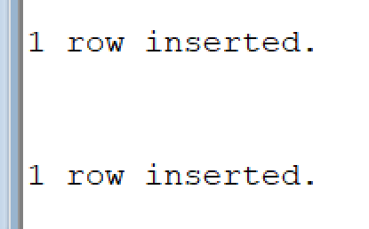

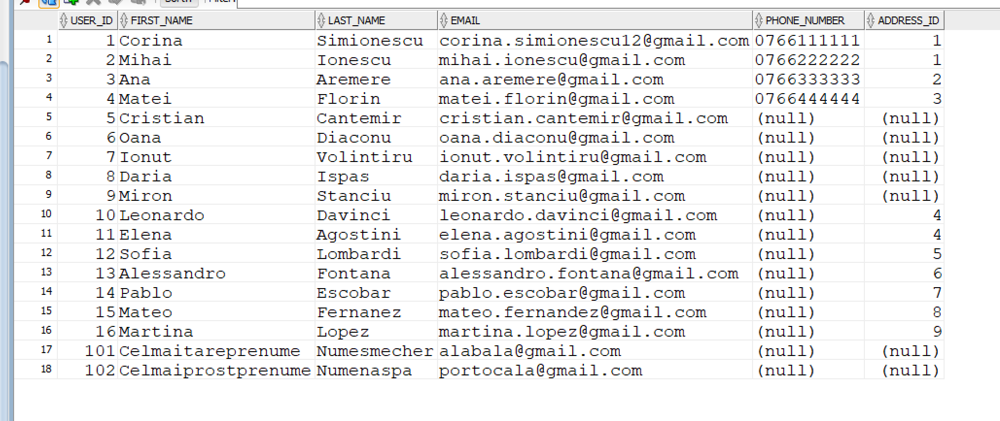

### **4.3. AFISARE VALOARE CURENTĂ A SECVENȚEI**

-- Afisare valoare curenta a secventei create anterior

SELECT SEQ_NR_USER.CURRVAL FROM DUAL;

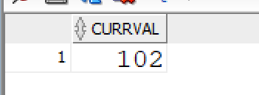

-- Modificarea pasului de incrementare si valoarea maxima a secventei anterioare

ALTER SEQUENCE SEQ_NR_USER INCREMENT BY 10;

ALTER SEQUENCE SEQ_NR_USER MAXVALUE 5000;

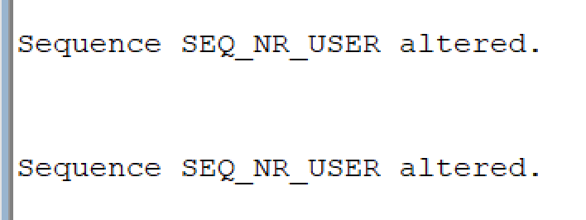

-- Exemplificare ca s-a marit pasul de incrementare

INSERT INTO Z_USERS (USER_ID, FIRST_NAME, LAST_NAME, EMAIL)

VALUES(SEQ_NR_USER.NEXTVAL, 'Celmaiprostprenume', 'Numenaspa', 'portocala@gmail.com');

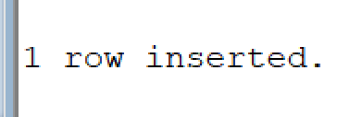



SELECT SEQ_NR_USER.CURRVAL FROM DUAL;

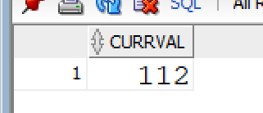

### **4.4. STERGERE SECVENȚĂ**

DROP SEQUENCE SEQ_NR_USER;

